

STANDARD OPERATING PROCEDURES
(SOP)

For the

DIRECTORATE OF CONFERENCE AND PROTOCOL
(DCP)

Table of Contents
Abbreviations 3
Definition of Terms 4
List of Forms and Templates 5
Preambles 6
1. Background 7
1.1. Introduction 7
1.2. Mission and Vision 7
1.3. Description of Organisation 7
1.4. Purpose and Scope 8
1.5. DCP Stakeholder: Internal and External 8
1.6. Directorate’s Roles and Responsibilities 9
2. Work Procedure and Output 11
2.1. Office of the Director 11
2.1.1. Purpose, Scope and Responsibilities 11
2.1.2. Process, People, Turnaround Time (TAT) and Expected Output 12
2.2. Conference Division 32
2.2.1. Purpose, Scope and Responsibilities 32
2.2.2. Process, People, Turnaround Time (TAT) and Expected Output 33
2.3. Protocol Division 54
2.3.1. Purpose, Scope and Responsibilities 54
2.3.2. Process, People, Turnaround Time (TAT) and Expected Output 55
2.4. Language Division 73
2.4.1. Purpose, Scope and Responsibilities 73
2.4.2. Process, People, Turnaround Time (TAT) and Expected Output 74
2.4.2.1. Interpretation Section 74
2.4.2.2. Translation Section 85
3. Appendices 90
3.1. Logistics Delivery Assessment Form: Language Division 90
3.2. Logistics Delivery Assessment Form: Conference Division 91
3.3. Logistics Delivery Assessment Form: Protocol Division 92
3.4. Meeting Logistics Details Form 93
3.5. Delegate Feedback Form 94
3.6. ECOWAS Meeting Assessment Form 95
3.7. Assessment Logistics Preparation Sheet 96
3.8. Form for Request for Issuance of Ticket for Freelance Interpreters 96
3.9. Virtual Meeting Request Form 97

Abbreviations

Abbreviations | Descriptions
CERPAC | Combined Expatriate Residence Permit and Aliens Card
CIS | Commissioner for Internal Services
DAGS | Directorate of Administration and General Service
DBT | Directorate of Budget & Treasury
DCP | Directorate of Conference and Protocol
ECODOCS | ECOWAS paperless Documentation System
ECOWAS | Economic Community of West African States
ETA | Estimated Time of Arrival
EU | European Union
FAAN | Federal Airports Authority of Nigeria
GRN | Goods Receipt Notes
HOM | Head of Mission
HQ | Headquarters
LA | Language Assistant
LC | Language Coordinator
LD | Language Division
MLD | Meetings Logistics Details
NIN | National Identification Number
NV | Note Verbale
PA | Protocol Assistant
PAPS | Political Affairs, Peace and Security
PO | Purchase Order
PPO | Principal Programme Officer
PR | Purchase Request
SIE | Simultaneous Interpretation Equipment
SOP | Standard Operating Procedure
TAT | Turnaround Time
TBD | To Be Decided
TD | Technical Directorate
TVM | Travel Request Module
UK | United Kingdom
USA | United States of America
VOA | Visa on Arrival

Definition of Terms

Terms | Definition
Day | A standard workday is defined as 8 hours, generally from 9:00 AM to 5:00 PM, including a 1-hour lunch break. Adjustments may be made to accommodate specific departmental or project needs
Director | Director of the Directorate of Conference and Protocol

List of Forms and Templates

# | Description | Purpose
1 | Meetings Logistics Details Form (MLD-Form) | For requisition of meeting resources.
2 | Delegate Feedback Form (Questionnaire) | For obtaining meeting feedback from Participants.
3 | Logistics Delivery Assessment Form  (Conference Division) | For obtaining meeting feedback from Conference Division on the deployed meeting resources.
4 | Logistics Delivery Assessment Form  (Language Division) | For obtaining meeting feedback from Language Division on the deployed meeting resources.
5 | Logistics Delivery Assessment Form  (Protocol Division) | For obtaining meeting feedback from Protocol Division on the deployed meeting resources.
6 | Assessment Logistics Preparation Sheet | For assessing logistics before the meeting.

Preambles

The Directorate of Conference and Protocol (DCP) is a technical and service support unit performing under the mandate of the Economic Community of West African States (ECOWAS) Commission.

DCP provides technical expertise and specialised know-how to support planning and hosting of regional conferences of the Commission, language translation and interpretation activities and deployment of protocol services for the ECOWAS Commission. It also helps mobilising participation of the regional state communities and committees based on a strategic vision. Through this, DCP aims at strengthening the ECOWAS Commission, enhancing service delivery, and activating the strategic conference planning and protocol function of the ECOWAS Commission

DCP is a service hub of the ECOWAS Commission and comprises a team of professionals, who are technical, translation and conference planning experts who are generally hired from Member States of the Commission.

DCP’s workforce and workflow are deeply rooted in the area in which it operates, thereby contributing to increased ownership and buy-in of both ECOWAS Commission officials and partner organisations/stakeholders throughout the process of developing ECOWAS Commission’s conference and protocol policies and projects.

SOP Preparation and Approval Matrix

Version | Authority | Signature and Date
First | DCP

Background

Introduction

This section provides an overview of the Directorate of Conference and Protocol (DCP) at the Economic Community of West African States (ECOWAS) and its importance. DCP is a crucial component of the ECOWAS having the responsibility for managing all aspects of conferences, meetings, and official events and ensuring appropriate protocols are observed during all ECOWAS activities and events.

This Standard Operating Procedure (SOP) document outlines the processes, guidelines, and best practices for the efficient and effective operation of DCP.

Mission and Vision

The Directorate of Conference and Protocol (DCP) exists to facilitate the effective delivery of conferencing and protocol services to the ECOWAS Commission, driving administrative optimisation and sustainable development outcomes.

Description of Organisation

DCP is structured into three (3) divisions—Conference, Protocol and Language as shown in the below Figure.
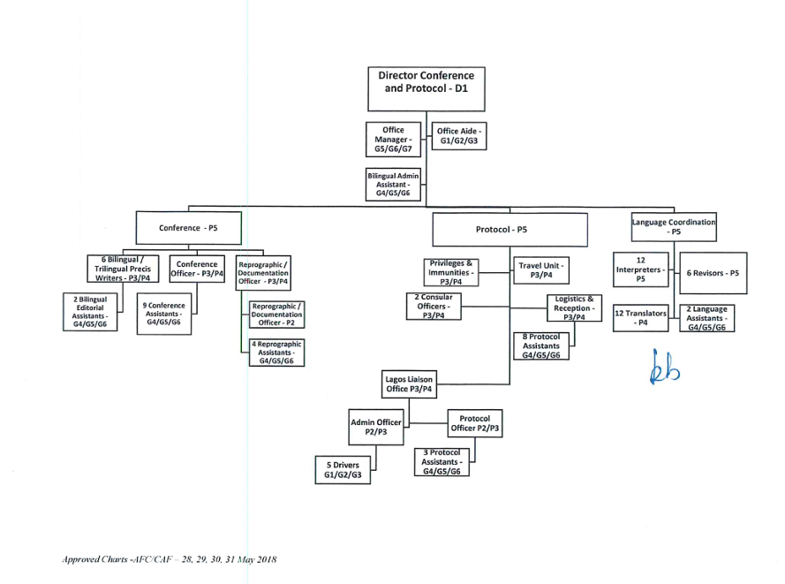

Purpose and Scope

Purpose: This aims to:
- Establish standardised procedures for conference management and protocol activities within ECOWAS.
- Ensure consistency and professionalism in all DCP operations.
- Facilitate smooth coordination between the DCP, other ECOWAS departments, and external stakeholders.
- Provide a reference guide for all DCP staff and relevant ECOWAS personnel.

Scope: This SOP shall apply to all:
- Staff members of the Directorate of Conference and Protocol.
- ECOWAS personnel involved in organizing or participating in conferences, meetings, and official events.
- Conference and protocol-related activities conducted by ECOWAS, both internally and externally.

DCP Stakeholder: Internal and External

Directorate’s Roles and Responsibilities

Work Procedure and Output

Office of the Director

Purpose, Scope and Responsibilities

Purpose

- To ensure efficient and effective management of conferences, meetings, and protocol services for ECOWAS.
- To provide support for all statutory, technical meetings and all events, including
- Meeting logistics
- Language and documentation services
- Protocol logistics, consular services and travel services
- To manage and provide related services in relation to the Headquarters Agreement and liaising with host government in connection with the immunities and privileges enjoyed by both the Commission and staff (in liaison with human resources and general administration).

Scope

This SOP applies to the office of the Director, Conference and Protocol and staff members involved in conference and protocol services.

Responsibilities

Key Thematic Steps- Office of the Director

Process, People, Turnaround Time (TAT) and Expected Output

Request 1: Preparation of Internal Memoranda on behalf of Directorate/Management

Thematic Steps | Process | People | Turnaround Time | Expected Output
- Planning | - Memo is received, time/date stamped and acknowledged in Director's office by the Office Aide | - Office aide | 10 minutes | Approved Memo
- Implementation | - Office Aide sends to the Director who minutes/instructs accordingly to officer responsible for related task | - Office aide | 15 minutes | Minuted Memo
- Implementation | - Office Aide dispatches minuted memo to officers responsible  OR  - Office Manager or Administrative Assistant prepares draft memo and sends draft to Director for review | - Office aide  - DCP staff  - Director | 1 day | Acknowledgment copy of dispatch/ dispatch register
- Implementation | - Director reviews, amends if need be and returns to Office Manager or Administrative Assistant for production of final draft  OR  - Director finalizes, signs and dispatches electronically while copying office email to constitute file copy, for archiving by Office Manager and Office Aide | - Office Manager  - Office Aide  - Admin Assistant  - Director | 2 days | Email notification/ acknowledgment copy of hard copy dispatch
- Implementation | - Office Aide/ Office Manager/ Admin Assistant/ Director dispatches to destination (sometimes electronically) while ensuring acknowledgement. | - Office Manager  - Office Aide  - Admin Assistant | For document received same day, not more than 2 hours. | Document is officially dispatched.
- Implementation | - In the absence of electronic acknowledgement, Office Manager or Admin Assistant sends a reminder after 3 working days | - Office Manager  - Admin Assistant | After 3 working days | Reminder is officially sent
- Report, Evaluation and Review | - Director checks completion of processes | - Director  - Office Manager  - Office Aide  - Admin Assistant | 24 hours | All processes completed or Director requests adjustment
Total Lead Time |  |  | 4 days

Request 2: Receipt of incoming Correspondences and Requests

Thematic Steps | Process | People | Turnaround Time | Expected Output
- Planning | - Memo is reviewed for receipt by Office Manager for hard copies  OR  - Office Aide/ Office Manager/ Admin Assistant/ Director performs same action for electronic receipt of request | - Office aide  - Office manager  - Admin Assistant  - Director | 30 Minutes | The memo is officially registered in DCP Register and in OneDrive incoming and outgoing folder.
- Implementation | - Memo without necessary supporting documents/wrongly transmitted is returned to Client Directorate  OR  - Director performs same action for electronic receipt of request | - Office aide  - Director | Within the Commission- 20 Minutes  Outside of the Commission - 2 Days | Within the Commission, document is returned by office aide.  Outside the Commission, document is electronically returned by office aide.
- Implementation | - Memo with all supporting documents is received and acknowledged in incoming register by Office Aide or electronically by Director | - Office Aide  - Office Manager  - Admin Assistant  - Director | 30 Minutes | Within the Commission, document is returned by office aide.  Outside the Commission, document is electronically returned by office aide.
- Implementation | - Office Aide submits memo to Director for action with summary of request  - Director acts on request/minutes memo to appropriate DCP staff/destination  - Director, when acting on request electronically, copies DCP office email | - Office aide  - Office manager  - Admin assistant  - Director | 4 Days | Director initiates implementation of request.
- Implementation | - Office Aide, Office Manager, Admin Assistant receives treated memo, registers, scans, and produces copy of files  - Office Aide, Office Manager, Admin Assistant generates hard copy for dispatch and archiving or for archiving alone | - Office aide  - Office manager  - Admin assistant | 1 day | The memo is officially registered in DCP Register and in OneDrive incoming and outgoing folder.
- Implementation | - Office Aide archives hard/electronic copy | - Office Aide | 1 day | The memo is officially registered in DCP Register and in OneDrive incoming and outgoing folder.
- Implementation | - Office Aide dispatches duly registered memo to destination | - Office Aide | Within the Commission- 1 Day  or  Outside of the Commission - 3 Days (based on feedback from Registry) | The memo is officially registered in DCP Register and in OneDrive incoming and outgoing folder.
- Implementation | - Office Aide delivers memo to destination and obtains acknowledgement in outgoing register | - Office Aide | Within the Commission- 1 Day  or  Outside of the Commission - 3 Days (based on feedback from Registry) | The memo is officially registered in DCP Register and in OneDrive incoming and outgoing folder.
- Report, Evaluation and Review | - Director/Office Manager and Office Aide continuously review daily dispatch of documents. | - Director  - Office Manager  - Office Aide | 1 Day | Outgoing correspondence is effectively dispatched to appropriate quarters
Total Lead Time |  |  | 15 days

Request 3: Review of Notes Verbale (NV) and Issuance of NV Numbers

Thematic Steps | Process | People | Turnaround Time | Expected Output
- Planning | - Director receives from PPO Protocol soft copy of draft NV with supporting documents where necessary | - Director, office manager  - Office aide | 2 Days | Note Verbale is received with supporting documents where necessary.
- Planning | - Director receives soft copy of NV from Office Manager | - Director  - Office manager | 10 minutes | Note Verbale is received with supporting documents where necessary.
- Implementation | - Director reviews send back to PPO Protocol for production of final hard copy while directing Office Manager to provide reference number | - Director, office manager  - Office aide | 1 day | Reviewed NV is sent back.
- Implementation | - Director receives final version for initialling | - Director  - Office aide  - Admin assistant | 10 minutes | Reviewed NV is received by Protocol/Office Manager
- Implementation | - Director dispatches initialled Note Verbale to Protocol through OA/ OM, Admin | - Director, office manager  - Admin Assistant  - Office aide | 10 minutes | Initialled NV is received by Protocol.
- Implementation | - Office Aide / Office Manager obtain Stamp from Office of Vice-President, Director of Cabinet or External Relation | - Office aide  - Office manager | 3 days | Initialled NV is stamped.
- Implementation | - Initialled Note Verbale is dispatched to Protocol Division | - Office aide | 10 minutes | Initialled and stamped NV is available for dispatch to, and receipt by recipient.
- Report, Evaluation and Review | Director checks with PPO Protocol/Office Manager or requests acknowledgement copy from Protocol Division | - Director  - PPO Protocol | 1 Day | Initialled and Stamped NV is acknowledged by recipient.
Total Lead Time |  |  | 5 days

Request 4: Supervision of Preparations for Statutory Meetings and other Official Events
Thematic Steps | Process | People | Turnaround Time | Expected Output
- Planning | - Admin Assistant recalls approved dates for Statutory Meetings by … | - Admin assistant | 2 working days | Admin Assistant submits approved dates for Statutory meetings.
- Implementation | - Director reviews and returns for production of final draft and production of cover memo by OM/ Admin Assistant | - Office manager  - Admin assistant | 2 days | Final draft of internal memo to management is ready for signature.
- Implementation | - OM submits final correspondence and relevant cover memo to Director for her signature | - Director  - Office manager  - Admin Assistant  - Office aide | 30 minutes | Final draft of internal memo to management is ready for dispatch.
- Implementation | - Director sends preliminary version of correspondence intended for President’s approval to Commissioner for review and the electronical copy to EA of Supervising Commissioner | - Director  - Office Aide  - Office Manager | 1 day | Proposed dates sent to Management for review and instruction
- Implementation | - Upon receipt of Supervising Commissioner’s amendments, Director adjusts as necessary with the support of Admin Assistant and Office Manager | - Director  - Office manager  - Admin assistant | 1 Day | Document reflecting dates adjusted by Management is available.
- Implementation | - OM prepares cover memo to accompany final versions to be dispatched to Supervising Commissioner | - Office manager | 1 Day | Cover Memos and Final versions are available.
- Implementation | - Director signs cover memos, while checking again accompanying final versions | - Director | 30 minutes | Signed cover memos and Final versions available to be sent to Management.
- Implementation | - Office Aide dispatches to Supervisoring Commissioner | - Office aide  - Office manager  - Admin assistant | Two hours | Signed cover memos and Final versions are dispatched.
- Report, Evaluation and Review | Director reviews all processes for completion with Office Manager, Office Aide and Admin Assistant | - Director  - Office manager  - Office Aide  - Admin assistant | Two hours | All processes are completed.
Total Lead Time |  |  | 7 days

Request 5: Preparations for Statutory Meetings/ Official Events

Thematic Steps | Process | People | Turnaround Time | Expected Output
- Planning | - Receive reaction from Management | - Director | 1 Day
- Implementation | - Upon receipt of Management/Supervising Commissioner’s reaction to the meeting dates, Director adjusts as necessary with the support of Admin Assistant and Office Manager | - Director  - Office Manager  - Admin Assistant  - Office Aide | 1 Day | The dates are amended, where necessary
- Implementation | - Director amends and returns for production of final accepted dates and production of cover memo by OM/ Admin Assistant | - Director  - Office Manager  - Admin Assistant  - Office Aide | 30  minutes | Final accepted dates are prepared
- Implementation | - OM prepares cover memo to accompany final accepted dates to be dispatched to Supervising Commissioner | - Director  - Office Manager  - Admin Assistant  - Office Aide | 20 minutes | Cover Memo to accompany final accepted dates is produced
- Implementation | - OM submits accepted dates and relevant cover memo to Director for her signature | - Director  - Office Manager  - Admin Assistant  - Office Aide | 10 minutes | Relevant cover memo is signed
- Implementation | - Director sends final accepted dates for President’s information through Supervising Commissioner for review and the electronical copy to the EA of Supervising Commissioner | - Director  - Office Manager  - Admin Assistant  - Office Aide | 20 minutes | Final accepted dates are dispatched to Supervising Commissioner with EA in copy
- Implementation | - Once President’s confirmation of of the dates is received, Director informs DCP colleagues | - Director  - Office Manager  - Admin Assistant | Two hours | All DCP Staff are informed.
- Implementation | - Director instructs Office Manager to prepare draft correspondence for Management to inform all Community Institutions of the approved dates | - Director  - Office Manager  - Admin Assistant | 1 day | Final Memos providing information are ready for signature.
- Implementation | - Final versions of memos accompanied by signed cover memo are dispatched to Management | - Office Manager  - Admin Assistant  - Office Aide | 1 day | Final versions are in possession of Management.
- Implementation | - Director instructs HOD Conference to approach DCP colleagues and support Directorates for expression of needs | - Director  - HOD Conference  - Office Manager | 1 day | HOD Conference receives instruction to collate all statutory meeting needs.
- Implementation | - Director instructs HOD Conference to prepare a draft budget reflecting the collated needs, memorandum of understanding on organization of ECOWAS meetings, the approved standard rates for goods and services, the rules of procedure for the governing bodies and the order of precedence | - Director  - HOD Conference | 1 day | The draft budgets are received.
- Implementation | - Director reviews draft budget and where necessary returns to HOD Conference for adjustment. | - Director  - Office Manager  - HOD Conference  - Admin Assistant  - Office Aide | 1 day | HOD Conference insert necessary adjustment where required
- Implementation | - The reviewed budget reflecting Director’s amendments is returned | - Director  - Office Manager  - Admin Assistant  - Office Aide | 1 day | Pre final version is ready for submission to Management.
- Implementation | - Director instructs the Office Manager/ Admin Assistant to send the pre-final version of budgets for Statutory Meetings to Management | - Director  - Office Manager  - Admin Assistant  - Office Aide | 1 day | Management receives pre-final version of budgets for Statutory Meetings.
- Implementation | - Upon receipt of Management/Supervising Commissioner’s amendments, Director adjusts as necessary with the support of Admin Assistant and Office Manager | - Director  - Office Manager  - Admin Assistant  - Office Aide | 1 day | The pre-final version of budgets is amended
- Implementation | - Director amends and returns for production of final draft budgets and production of cover memo by OM/ Admin Assistant | - Director  - Office Manager  - Admin Assistant  - Office Aide | 1 day | Final draft budget is produced
- Implementation | - OM prepares cover memo to accompany final draft budgets to be dispatched to Supervising Commissioner | - Director  - Office Manager  - Admin Assistant  - Office Aide | 1 day | Cover Memo to accompany final draft budgets is produced
- Implementation | - OM submits final draft budget and relevant cover memo to Director for her signature | - Director  - Office Manager  - Admin Assistant  - Office Aide | 1 day | Relevant cover memo is signed
- Implementation | - Director sends final draft budget intended for President’s approval to Supervising Commissioner for review and the electronical copy to EA of Supervising Commissioner | - Director  - Office Manager  - Admin Assistant  - Office Aide | I day | Final draft budgets are dispatched to Supervising Commissioner with EA in copy
- Implementation | - Director instructs OM/Admin Assistant to prepare an electronic and modifiable version of List of Participants for circulation to all departments. | - Director  - Office Manager  - Admin Assistant | 1 day | The electronic list is ready for dispatch.
- Implementation | - Director reviews the List of Participants and instructs for any adjustment to be made. | - Director | 1 day | The electronic version of the list is circulated to all Directors for their nominations.
- Implementation | - Director receives the populated list and finalizes by the deadline indicated. | - Director  - Office Manager  - Admin Assistant |  | The pre-final list is ready for review by Management.
- Implementation | - Director sends preliminary version of List of Participants intended for President’s approval to Commissioner for review and the electronical copy to EA of Supervising Commissioner | - Director  - Office Aide  - Office Manager | 1 day | Preliminary version of List of Participants is sent to Management for review and instruction
- Implementation | - Upon receipt of Management/Supervising Commissioner’s amendments to the pre-final List of Participants, Director adjusts as necessary with the support of Admin Assistant and Office Manager | - Director  - Office Manager  - Admin Assistant  - Office Aide | 1 day | The pre-final List of Participants is amended
- Implementation | - Director amends and returns for production of final List of Participants and production of cover memo by OM/ Admin Assistant | - Director  - Office Manager  - Admin Assistant  - Office Aide | 1 day | Final List of Participants is produced
- Implementation | - OM prepares cover memo to accompany final List of Participants to be dispatched to Supervising Commissioner | - Director  - Office Manager  - Admin Assistant  - Office Aide | 1 day | Cover Memo to accompany final List of Participants is produced
- Implementation | - OM submits final List of Participants and relevant cover memo to Director for her signature | - Director  - Office Manager  - Admin Assistant  - Office Aide | 1 day | Relevant cover memo is signed
- Implementation | - Director sends final List of Participants intended for President’s approval to Supervising Commissioner for review and the electronical copy to EA of Supervising Commissioner | - Director  - Office Manager  - Admin Assistant  - Office Aide | I day | Final List of Participants is dispatched to Supervising Commissioner with EA in copy
- Implementation | - Once final approved List of Participants is received, Director instructs the Office Manager to circulate the List of Participants | - Director  - Office Manager  - Admin Assistant | 2 days | All recipients of correspondence are informed of their participation.
- Implementation | - Director instructs the Office Manager to send the List of Participants to Communication Directorate for circulation to Staff | - Director  - Officer Manager  - Admin Assistant  - PPO Communication | 1 day | All staff approved for participation in the meeting are duly informed.
- Implementation | - Director instructs the Reproduction Unit to prepare badges for all participants for AFC and Technical Meetings respecting ECOWAS Commission corporates design/ designs to guide Host Government for Ministerial and Summit level meetings | - Director  - Officer Manager  - Admin Assistant  - HOD Conference  - Head, ECOWAS National Office | 1 day | Instruction to prepare the designs is issued
- Implementation | - Director instructs all HODs to submit the schedule of duty of each DCP staff member for Pre, during and post Statutory Meeting. | - All DCP Staff | 2 days | All schedules of meetings are clearly indicated
- Implementation | - Director instructs PPO Protocol to provide list of recommended hotels and negotiated rates. | - Director  - PPO Protocol | 1 day | Instruction is received by Protocol.
- Implementation | - Director instructs HOD Conference to provide updated and active meeting registration link for insertion in Administrative Note. | - Director  - HOD Conference  - Admin Assistant | 1 day | The updated and active registration link is received.
- Implementation | - Director instructs the Office Manager to prepare and send the draft memo to other support directorates (ITS, DAGS, Communication) | - Director  - Office Manager  - Office Aide | 1 day | The final memo to support directorates is dispatched.
- Implementation | - The Admin Assistant and OM prepares the draft Administrative Note for delegates inserting the list of recommended hotels, ECODOCS Login details and updated meeting registration link and currency exchange rates and expected weather. | - Office Manager  - Administrative Assistant | 7 days | The Draft Administrative Note is ready.
- Implementation | - The draft Admin Note is submitted to Director for review | - Office Manager  - Administrative Assistant | 1 day | The Draft Admin Note is ready.
- Implementation | - Director instructs Admin Assistant/OM to electronically dispatch reviewed and approved Administrative Note to delegates. | - Director  - Admin Assistant  - Office Manager | 1 day | Admin Note is dispatched to delegates electronically.
- Implementation | - Once approved meeting dates are received, OM prepares invitation letters and submits to Director -still within PeC’s Purview | - Office Manager | 10 days | The invitation letters are prepared
- Implementation | - Admin Assistant referencing archived meetings on ECODOCS and translated draft agendas of upcoming statutory meetings, prepares meeting titles reflecting the correct edition in all 3 working languages. | - Admin Assistant  - ECODOCs Team | 2 days | Meeting titles and dates in all 3 languages are prepared on DCP letterhead.
- Implementation | - Document reflecting approved meeting titles and dates is circulated to all relevant stakeholders (National office in host member state, Protocol Division, Conference Division, all staff of DCP, Communication Directorate) | - Office Manager  - Admin Assistant  - Office Aide | 2 days | Relevant stakeholders receive the meeting title documents
- Implementation | - Director convenes initial preparation meeting with HODs and reviews preparations of all deliverables, Including any required liaison with support directorate and deliverables from Director's office itself | - Director  - HODs  - Team Leads  - Staff of Office DCP | 2 days | Initial preparation meeting holds
- Implementation | - Director convenes meeting with all DCP Staff to review overall preparedness and readiness of Statutory Meetings | - Director  - All DCP Staff | 1 day | General Staff meeting specifically on preparedness of statutory meetings hold.
- Implementation | - Director request (proposes) and receive dates for meeting with Local Organizing Committee (LOC) and sends signed MOU on the Organisation of ECOWAS Meetings to Host Government | - Director  - LOC of host government | 3 days | Dates for meeting with LOC is agreed upon.
- Implementation | - Director instructs Office Manager to prepare memos to invite Staff of the support directorates to participate in the meeting of the LOC, while forwarding to support directorates signed Memorandum of Understanding (Base document for collaboration for Host Government) | - Director  Office Manager | 1 day | Memo inviting support directorates is dispatched along with copy of signed MOU to appropriate quarters
- Implementation | - Directorate Conference and Protocol leads the ECOWAS Commission delegation to participate in the LOC meeting | - ECOWAS Delegation  - LOC of host government | 1 day | The meeting holds, MOU is reviewed, face recognition is achieved, exchanges of contact information is done.
- Implementation | - For Statutory Meeting outside HQ, Director approaches management for approval for DCP advance team to proceed for identification and inspection of venues in the member state hosting the meeting or Chairing the Authority - still within PeC’s Purview | - Director  - DCP Advance team | 2 days | Management’s approval for deployment of advance team.
- Implementation | - Director reviews facility inspections report and makes recommendation to Management and DAGS for designation and engagement of service providers | - Director  - Office Manager  - Office Aide | 3 days | Dispatch of facilities inspection report.
- Implementation | - Director invites Management to conduct final check of facilities and arrangements- still within PeC’s Purview | - Office Manager  - Office Aide | 1 day | Invitation to Management is extended.
- Implementation | - While meeting/event is ongoing Director monitors smooth functioning of all meeting pillars (payments, bills, documentation, accreditation, signature of final reports, etc) | - Director  - HODs  - Team leads | One week ahead of commencement of meeting to One week after the meeting | All DCP deliverables are met
- Implementation | - Director supervises the dismantling of meeting | - Director  - HODs  - Team leads | 4 days | All DCP deliverables are met
- Implementation | - Director receives analysis of feedback and assessment forms, and reviews DCP procedures accordingly. | - Director  - DCP Staff  - All Participants including Member States. | 5 days | Measurable feedback is obtained and identification of best practices and areas of improvement.
- Report, Evaluation and Review | - Review and aggregate reports | - Director  - HODs  - Team leads | 1 day | Report
Total Lead Time |  |  | 10 days

Request 6: Preparation and Review of Contributions to Reports

Thematic Steps | Process | People | Turnaround Time | Expected Output
- Planning | - Receive request | - Director
- Implementation | - Director receives instructions from Management to prepare contributions | - Director  - Office Manager  - Office Aide | 1 day | Contributions are received
- Implementation | - Director requests Director's Office support staff to provide previous versions where it exists/prepare preliminary draft | - Director  - Office Manager  - Admin Assistant | 1 day | Previous versions are received
- Implementation | - Director requests elements from divisions where necessary in electronic version | - Director  - HODs  - Team leads | 2 days | Elements are received
- Implementation | - Director directs support staff to merge all elements and prepare second preliminary draft | - Director  - Office Manager  - Admin Assistant | 1 day | Second preliminary draft is prepared
- Implementation | - Director reviews second preliminary draft and dispatches to support staff/Office Manager/Documentation Division for formatting | - Director  - Office Manager  - Admin assistant  - Reproduction unit | 2 days | Reviewed second preliminary draft is formatted
- Implementation | - Director receives formatted version | - Director  - Office Manager | 1 day | Formatted preliminary draft is ready
- Implementation | - Director forwards DCP contribution to appropriate quarters (electronic version or hard copy) | - Director  - Office Manager  - Admin Assistant  - Office Aide | 1 day | DCP Contribution is dispatched to appropriate quarters
- Report, Evaluation and Review | - All DCP contributions to reports are available and accurate | - Director  - HODs  - Team leads  - Office Manager  - Admin Assistant | 2 days | All DCP reports are available and accurate
Total Lead Time |  |  | 3 days

Request 7: Preparation of Concept Notes/Terms of Reference

Thematic Steps | Process | People | Turnaround Time | Expected Output
- Planning | - Receive request | - Director | 1 day
- Implementation | - Director receives instruction from Management/Technical directorate | - Director | 1 day | Management instruction is received.
- Implementation | - Director requests draft concept note/terms of reference from relevant HOD / Team Leads in implementation of approved budget/activity plan | - Director  - HODs  - Team leads | 2 days | Instruction is given to HODs, and Team Leads.
- Implementation | - Director reviews draft received and instructed relevant HOD/Team Leads to prepare final version | - Director  - HODs/Team leads | 3 days | Final version of document is prepared.
- Implementation | - Director dispatches completed document to appropriate quarters | - Director  - Office Manager  - Admin Assistant  - Office Aide | 1 day | Document is dispatched to appropriate quarters
- Report, Evaluation and Review | Director ensures all concept note and TOR relating to activities in the approved work plan is available | - Director  - HODs/Team  - Admin Assistant | 2 days | The concept note and TOR are available.
Total Lead Time |  |  | 5 days

Request 8: Preparation of Internal Meetings

Thematic Steps | Process | People | Turnaround Time | Expected Output
- Planning | - Director instructs Office Manager or Admin Assistant to prepare relevant background information, notice of meeting, draft agenda and work program | - Director  - Office Manager  - Admin Assistant | 3 days | Correspondences are prepared
- Implementation | - Director reviews preliminary background information and supporting document, amending where necessary or issuing instruction to DCP staff for finalisation. | - Director  - Office Manager  - Admin Assistant | 2 days | Review is conducted
- Implementation | - Director directs Office Manager to dispatch Notice of Meeting, Meeting Link, Agenda, Work Program and any supporting documents | - Director  - Office Manager | 1 day | Notice of Meeting, Meeting Link, Agenda, Work Program and any supporting documents are dispatched
- Implementation | - Director instructs Office Manager or Admin Assistant to prepare action points for Director's/ HODs/Team Lead's own use | - Director  - Office Manager  - Admin Assistant | 3 Days | Action points for Director, HODs and Team Leads are prepared.
- Implementation | - Office Manager or Admin Assistant activates meeting recording and transcription on the virtual platform | - Office Manager  - Admin Assistant | Immediately Meeting Called to Order | Meeting is recorded
- Implementation | - Director moderates the meeting | - Director | For the Duration of the Meeting | Meeting moderated
- Implementation | - Office Manager or Admin Assistant listens to the recordings of the meeting and generates action points, and agenda of the next meeting, then sends to the Director for review | - Office Manager  - Admin Assistant | 3 Days | Action point is generated, and agenda is drafted
- Implementation | - Director reviews the report of meeting, and action points to the Office Manager or Admin Assistant | - Director  - Office  - Manager  - Admin Assistant | 3 Days | Actions Points are available
- Report, Evaluation and Review | Director reviews number of action point treated | - Director  - HODs  - Team leads | 2 Days | Action points are reviewed
Total Lead Time |  |  | 8 days

Request 9: Document Upload, Population and Management of ECODOCS for Paperless Meeting

Thematic Steps | Process | People | Turnaround Time | Expected Output
- Planning | Director receives approved draft agenda from Management | - Director  - Office Manager  - Admin Assistant  - Office Aide | 1 Day | Approved Agenda is available
- Implementation | - Director sends approved agenda to ECODOCS Team for review of details of Status of Documents spreadsheet  - Submit Draft Agenda for Management’s review and clearance  - Indicate document availability on ECODOCS to Management and facilitate session with Secretary General and President’s Office to jointly review Status of Documents and Translation | - Director  - ECODOCS Team | Continuously until the 15 Days to Meeting commencement date | Status of Documents spreadsheet is reviewed on a continual basis.
- Implementation | - Director instructs support staff to continuously adjust Status of Documents in line with President's instructions | - Director  - ECODOCS Team | Continuously until the 15 Days to Meeting commencement date. | Status of Documents spreadsheet is reviewed on a continual basis.
- Implementation | - Director instructs ECODOCS Team to format and upload documents in all three languages as against President's approval of agenda items  - Director continues to release documents as upload is completed by support staff | - Director  - ECODOCS Team  - Director  - ECODOCS Team | 12 days leading up to mandatory dates of ECODOCS document availability as provided by the Rules of Procedure | Agenda documents are formatted and uploaded to relevant meeting page on ECODOCS platform
- Implementation | - Director remains available to instruct ECODOCS Team for replacement/removal of any uploaded document | - Director  - ECODOCS Team | Continuous | Documents are uploaded in line with DCP’s directives.
- Implementation | - ECODOCS Team checks that system has automatically archived all documents and reviews meeting identifying details in the backend | - Director  - ECODOCS Team | No more than 5 days | Archived documents on ECODOCS are checked for inconsistencies in terms of meeting identifying details.
- Report, Evaluation and Review | - Director checks the availability of all documents on the relevant ECODOCS page of the meeting. | - Director | 1 Day | The fully populated page is available
Total Lead Time |  |  | 17 days

Conference Division

Purpose, Scope and Responsibilities

Purpose

To establish a standardized procedure for planning, organizing, and executing ECOWAS conferences, ensuring efficiency, effectiveness, and consistency.

Scope

This SOP applies to all ECOWAS conferences, meetings, and workshops organized by the ECOWAS Commission, its departments, and member states.

Responsibilities

Key Thematic Steps- Conference

Process, People, Turnaround Time (TAT) and Expected Output

Request 1: Compilation of Quarterly Calendar of Event
Thematic Steps | Process | People | Turnaround Time | Expected Output
- Pre-Conference | - Conference division through DCP requests for the activities for the quarter from office of the President | - Director  - HOD | 5 days | Work plan/Quarterly Budget Received
- Pre-Conference | - HOD assigns a conference assistant to extract detailed information from the approved work plan | - HOD  - Conference Assistant | 1 day | Conference Assistant Assigned
- Pre-Conference | - Assigned conference assistant draws up the draft quarterly calendar of events. | - Conference  Assistant | 1 week | Draft quarterly calendar of events produced
- Pre-Conference | - Conference Assistant submits draft quarterly calendar to HOD for vetting | - Conference Assistant  - HOD | 1 day | Draft quarterly calendar of events submitted to HOD
- Pre-Conference | - HOD sends draft calendar to the director for approval and circulates to other directorates | - HOD  - Director  - Other Directorates | 1 day | Quarterly calendar of events published
- Pre-Conference | - HOD allocates each conference assistance to a specific directorate(s) | - HOD  - Conference Assistants  - Other Directorates | 1 day | Conference Assistants allocated
- Pre-Conference | - Each conference assistant to liaise with his allocated directorate to confirm the meetings in the quarterly calendar and update with logistics (venue/ venue/ amount of days/number of participants) | - Conference Assistants  - Various directorates | 5 days | Meeting information confirmed
- Pre-Conference | - Assigned conference assistant undertakes checks at end of every month and update calendar when necessary. collation continues | - Conference assistant  - Directorate(s) focal person | 1 week | Meeting information updated
Total Lead Time |  |  | 1 month

Request 2: Budget Preparation
Thematic Steps | Process | People | Turnaround Time | Expected Output
- Pre-conference | - HOD receives instruction from Director to prepare budgets for all statutory /sectoral ministerial meetings | - HOD  - Director | 2 days | Instruction received by HOD
- Pre-conference | - HOD instructs Conference assistant to contact other DCP divisions/ support directorates involved, also client directorate to obtain all details necessary for budget preparation. | - HOD  - Conference Assistant  - Others Division  - Client Directorate | 2 weeks | Information for budget preparation collated
- Pre-conference | - Conference assistant prepares the draft budget and submits to HOD for vetting | - Conference Assistant  - HOD | 3 days | Draft budgets prepared
- Pre-conference | - HOD sends the prepared budget to Director for onward transmission to the technical directorate. | - HOD  - Director | 2 days | Draft budget sent
Total Lead Time |  |  | 3 weeks

Request 3a: Meeting at the Commission (Physical)- Meeting Logistics Arrangement and Support Service
Thematic Steps | Process | People | Turnaround Time | Expected Output
- Pre-Conference | - HOD receives approved memo/ meeting request form from Director | - DCP  - HOD | 1 day | Approved MRF received
- Pre-Conference | - HOD minutes of the meeting request to conference assistant in charge of necessary logistics preparation | - HOD  - Conference Assistant | 1 day | Logistics form completed
- Pre-Conference | - Conference assistant completes the logistics request form as against the approved budget and submits it to Director through the HOD | - Conference Assistant  - HOD  - DCP | 1 day | The logistics form received by DCP
- Pre-Conference | - Director approves and sends to admin directorate | - DCP | 1 day | DGAGS receives an approved logistics form
- Pre-Conference | - Logistics requested received from general admin and deployed by conference assistant assigned to the meeting | - Admin & General Service  - Conference Assistant | 1 day | Conference Assistant receives information from the support service
 | - Conference assistant requests and receives menu from identified caterer(s) and submits to HOD | - Conference Assistant  - HOD | 1 day | Menu submitted to HOD
 | - HOD with participation of conference assistant calls for meeting with caterer to discuss identified service points, timings, food distribution, presentation, packaging, number of wait staff, waste disposal etc. | - HOD  - Conference Assistant  - Caterer | 1 day | Identification of service points etc
Total lead time |  |  | 1 week

Request 3b: External Meeting (Physical) - Meeting Execution
Steps | Process | People | Turnaround Time | Expected Output
- Meeting execution | - Conference assistant holds duty station in the hall | - Conference assistant  - Hostesses | Duration of the meeting | The Conference Assistant oversees the meeting
- Meeting execution | - Conference assistant supervises support staff and monitors the smooth running of the meeting | - Conference assistant  - Support Staff | Duration of the meeting | The conference Assistant makes sure everything provided is in line with what was requested
 | - Conference Assistant supervises food and ensures timely delivery of food to meeting venue and informs focal persons whenever food is ready | - Conference assistant  - Support staff  - Meeting coordinator | Duration of the meeting | The Conference Assistant makes sure everything provided is in line with what was requested
Total Lead Time |  | Duration of the meeting

Request 3c: Meeting at the Commission (Physical) - Post-Meeting
Steps | Process | People | Turnaround Time | Expected Output
- Post Conference | C1- Bills Settling
- Post Conference | - Conference staff requests the bills from the service providers | - Conference staff | 1 day | Bills/ Invoice
- Post Conference | - Conference staff vet bills in line with the approved budget and submit to Director/coordinator for approval for onward transmission to Gen. Admin for payment preparation. | - Conference staff  - Director  - Coordinator  - General Administration and Services | 1 day | Vetted Bills/ Invoice (stamped CHECKED)
- Post Conference | - Conference staff fills feedback assessment form and submits it to the HOD conference for onward transmission to Director | - Conference staff  - HOD  - Director | 1 day | Filled Feedback Assessment Form
- Post Conference | - Conference staff fills out the service certification form and submits it to HOD for review and signature | - Conference staff  - HOD | 1 day | Filled Service Satisfaction Form
- Post Conference | - Conference staff ushers the service provider to the accountant for the payment | - Conference staff  - Service providers  - Accountant | 1 day | Payment Receipt
- Post Conference | C2- Feedback on Service Provider
- Post Conference | - Conference assistant takes a random number of feedback forms as a basis for analysing the service | - Conference Assistant  - Random Participants | 1 day | Filled Feedback Form
- Post Conference | - Conference assistant analyses the filled feedback forms | - Conference Assistant | 2 days | Report on analysed Feedback Form
- Post Conference | - Conference assistant presents and hands over to HOD for onward transmission to Director | - Conference Assistant  - HOD | 1 day | Acknowledgment copy of notification
- Post Conference | C3- Meeting Space Clearing
- Post Conference | - Conference/reproduction assistants initiate clearance of all conference materials by instructing ad hoc staff on the collection of all leftover documents and meeting materials | - Conference/reproduction assistants | At the end of the meeting | Filled Clearance Form
- Post Conference | - Conference/reproduction assistants with the help of support staff clear all used conference materials from all meeting spaces | - Conference/reproduction assistants  - Support Staff | At the end of the meeting | Inspection Report
- Post Conference | - Reproduction/conference assistants ensure proper shredding of all leftover documents | - Reproduction assistants | 1 day | Inspection Report
- Post Conference | - Reprographic officer/conference assistants ensure that all hired equipment is released to the service providers | - Reprographic officer | 1 day | Inspection Report
- Post Conference | - Conference assistant submits meeting assessment form to client directorate and receives completed form for dispatch to HOD and onward transmission to Director | - Conference Assistant  - HOD  - Client Directorate | 1 day | Meeting Assessment Form
- Post Conference | - Conference assistant submits meeting feedback form to HOD and receives completed form for dispatch to HOD for onward transmission to Director. | - Conference Assistant  - HOD | 1 day | Meeting Feedback Form
- Report, Evaluation and Review | Report, Evaluation and Review
- Report, Evaluation and Review | Prepare feedback |  |  | Report on deployed and evaluated catering services
Total Lead Time |  |  | 13 days

Request 4a: External Meeting (Physical Outside the Commission)- Meeting Logistics Arrangement: Support Service or Service Providers- Set up
Thematic Steps | Process | People | Turnaround Time | Expected Output
- Pre-Conference | - Approved memo/ meeting request form received from Director by HOD | - HOD | 1 day | Approved Memo
- Pre-Conference | - HOD assigns logistical arrangements to the Conference Assistant in charge. | - HOD  - Conference Assistant | 1 day | Logistics in place.
- Pre-Conference | - Conference Assistant sends email to designated service providers, which reflects the compilation of meeting logistic needs and other relevant details. Email is copied to HOD, DCP and Client/user directorate. | - Conference Assistant  - HOD  - DCP | 1 day | Logistics concluded
- Pre-Conference | - HOD notifies Director of any request to be made to resident representatives or /ECOWAS entities | - DCP  - HOD  - Resident Reps. office | 1 day | Ongoing  Logistics in place.
- Pre-Conference | - Conference Assistant/ Officer assesses for conformity with approval and negotiates, if necessary, until agreement is reached. | - Officer/Conference Assistant | 3 days | Logistics in place.
- Pre-Conference | - HOD/ Conference Officer/ Assistant leads inspection and walk through of meeting facilities. identification and allocation of offices and workspace, preparation of office space directory, labelling and room tagging | - HOD  - Conference officer/assistant | 1 Day | Meeting inspection concluded
- Pre-Conference | - HOD / Conference Officer/ Assistant sketches layout reflecting set-up & seating arrangement and shares with service provider for appropriate set-up to be done | - HOD  - Conference officer/assistant | 1 day | Meeting setup arrangement concluded
- Pre-Conference | - Conference officer/assistant prepares and places nameplates to reflect approved participants and order of precedence and seating plan. conference assistant guides hostesses to undertake labeling of seats and familiarization with designated seating areas | - Conference /Officer assistant  - Hostesses | 1 day | Meeting setup concluded
- Pre-Conference | - Conference Officer/Assistant guides hostesses to place writing kits on tables and any other folders/documents as indicated by Director | - Conference officer/assistant  - Hostesses | 1 day | Meeting hall in order
- Pre-Conference | - HOD to invite meeting coordinator/DCP/Management for final inspection | - HOD  - Management  - DCP  - Focal Persons |  | Inspection Report
Total lead time |  |  | 11 days

Request 4b: External Meeting (Physical Outside the Commission)
Steps | Process | People | Turnaround Time | Expected Output
- Meeting execution | - Conference assistant holds duty station in the hall | - Conference assistant  - Hostesses | Duration of the meeting | The Conference Assistant oversees the meeting
- Meeting execution | - Conference assistant supervises support staff and monitors the smooth running of the meeting | - Conference assistant  - Support Staff | Duration of the meeting | The Conference Assistant makes sure everything provided is in line with what was requested
 | - Conference Assistant supervises food and ensures timely delivery of food to meeting venue and informs focal persons whenever food is ready | - Conference assistant  - Support staff  - Meeting coordinator | Duration of the meeting | The Conference Assistant makes sure everything provided is in line with what was requested
Total Lead Time |  |  | Duration of the meeting

Request 4c: External Meeting (Physical outside the Commission) Post-Meeting
Steps | Process | People | Turnaround Time | Expected Output
- Post Conference | C1. Bills Settling
- Post Conference | - Conference staff requests the bills from the service providers | - Conference staff | 1 day | Bills/ Invoice
- Post Conference | - Conference staff vet bills in line with the approved budget and submit to Director/coordinator for approval for onward transmission for payment | - Conference staff  - Director  - Coordinator | 1 day | Vetted Bills/ Invoice (stamped CHECKED)
- Post Conference | - Conference staff fills feedback assessment form and submit to HOD conference for onward transmission to Director | - Conference staff  - HOD  - Director | 1 day | Filled Feedback Assessment Form
- Post Conference | - Conference staff fills the service satisfaction form and submit to HOD for review and signature | - Conference staff  - HOD | 1 day | Filled Service Satisfaction Form
- Post Conference | - Conference staff ushers the service provider to the accountant for the payment | - Conference staff  - Service providers  - Accountant | 1 day | Payment Receipt
- Post Conference | C2. Feedback on Service Provider
- Post Conference | - Conference assistant takes a random number of feedback form as a basis for analysing the service | - Conference Assistant | 1 day | Filled Feedback Form
- Post Conference | - Conference assistant analyses the filled feedback forms | - Conference Assistant | 2 days | Report on analysed Feedback Form
- Post Conference | - Conference assistant presents and hands over to HOD for onward transmission to Director | - Conference Assistant  - HOD | 1 day | Acknowledgment copy of notification
- Post Conference | C3. Meeting Space Clearing
- Post Conference | - Conference/reproduction assistants initiate clearance of all conference materials by instructing ad hoc staff on the collection of all leftover documents and meeting materials | Conference/reproduction assistants | At the end of the meeting | Filled Clearance Form
- Post Conference | - Conference/reproduction assistants with the help of support staff clear all used conference materials from all meeting spaces | - Conference/reproduction assistants  - Support Staff | At the end of the meeting | Inspection Report
- Post Conference | - Reproduction/conference assistants ensure proper shredding of all leftover documents | - Reproduction assistants | 1 day | Inspection Report
- Post Conference | - Reprographic officer/conference assistants ensure that all hired equipment is released to the service providers | - Reprographic officer  - Conference assistant | 1 day | Inspection Report
- Post Conference | - Conference assistant submits meeting assessment form to client directorate and receives completed form for dispatch to HOD and onward transmission to Director | - Conference Assistant  - HOD  - Client Directorate | 1 day | Meeting Assessment Form
- Post Conference | - Conference assistant submits meeting feedback form to HOD and receives completed form for dispatch to HOD for onward transmission to Director | - Conference Assistant  - HOD | 1 day | Meeting Feedback Form
- Report, Evaluation and Review | Report, Evaluation and Review
- Report, Evaluation and Review | Prepare feedback |  | 1 day | Report on deployed and evaluated conference set-up
Total Lead Time |  |  | 13 days
Request 5a: Virtual / Hybrid Meeting - Meeting Logistics Arrangement: Meeting Link and Refreshment
Steps | Process | People | Turnaround Time | Expected Output
- Pre-Conference | - Approved memo/ meeting request form received from DCP by HOD | - DCP  - HOD | 1 day | Request received
- Pre-Conference | - HOD minutes on the meeting request to the conference assistant in charge of the creation of virtual links & also to the conference assistant in charge of other logistics arrangement | - HOD  - Conference assistants | 1 day | The Conference Assistant receives the instructions
- Pre-Conference | - Conference assistant in charge of the link creation contacts the client directorate for other necessary information. | - Conference assistant  - Client directorate | 1 day | The Conference Assistant gets in touch with the client directorate
- Pre-Conference | - Conference assistant completes the logistics request form as against the approved budget and submits it to DCP through the HOD | - Conference assistant  - HOD  - DCP | 1 day | The logistics request form completed
- Pre-Conference | - The conference assistant in charge of the link creation receives from the client directorate accurate information for the link setup. | - Conference assistant  - Client directorate | 1 day | Link setup
- Pre-Conference | - DCP approves the logistics request form and sends it to the general admin directorate. conference assistants follow up on logistics deployment | - DCP  - General admin  - Conference assistant | 1 day | Logistic arrangement completed
- Pre-Conference | - Conference assistant designs the meeting link according to the received information | - Conference assistant | 1 day | Link created
- Pre-Conference | - Conference assistants forward the created link to the client directorate and copy DCP/ HOD/ other support division. | - Conference assistant  - DCP  - HOD  - Client directorate | 1 day | Completed link dispatched
- Pre-Conference | - Conference assistants forward the created meeting information to the conference assistant in charge of the creation of the dashboard who will complete and dispatch it to the HOD | - Conference assistants  - HOD | 1 day | Dashboard created
- Pre-Conference | - The conference assistant in charge of logistics contacts the service provider with the refreshment dispatch plan for his implementation. | - Conference assistant  - Service provider | 1 day | Information received
 | - Service providers install all equipment under the supervision of conference staff and its staff | - Conference staff  - IT staff  - Service providers | 1 day | All equipment installed
 | - Conference/ITS staff proceed on the dry run for all equipment, including for virtual meetings. | - Conference staff  - IT Staff  - Coordinator | Same day | Dry run completed
Total Lead time |  |  | 11 days

Request 5b: Hybrid / Virtual (Physical & Virtual Running Simultaneously)
Steps | Process | People | Turnaround Time | Expected Output
- Conference Execution (IN Meeting) | - The Conference Assistant opens Zoom and hosts the meeting till the end | - Conference Assistant | Duration of meeting | Zoom meeting has started
- Conference Execution (IN Meeting) | - During hybrid meetings, the Conference assistant holds a duty station in the hall and with the assistant of support staff | - Conference assistant  - Support Staff | Duration of meeting | Successful covering of the meeting
- Conference Execution (IN Meeting) | - Deploy refreshments | - Conference assistant  - Caterers | Duration of meeting
Total Lead Time |  |  | Duration of meeting

Request 5c: Hybrid / Virtual (Physical & Virtual Running Simultaneously) Post-Meeting
Steps | Process | People | Turnaround Time | Expected Output
- Post Conference | Bills Settling
- Post Conference | - Conference staff requests the bills from the service providers | - Conference staff | 1 day | Bills/ Invoice
- Post Conference | - Conference staff vet bills in line with the approved budget and submit to DCP/coordinator for approval for onward transmission for payment | - Conference staff  - DCP  - Coordinator | 1 day | Vetted Bills/ Invoice (stamped CHECKED)
- Post Conference | - Conference staff fills feedback assessment form and submits it to the HOD conference for onward transmission to DCP | - Conference staff  - HOD  - DCP | 1 day | Filled Feedback Assessment Form
- Post Conference | - Conference staff fills out the service satisfaction form and submits to HOD for review and signature | - Conference staff  - HOD | 1 day | Filled Service Satisfaction Form
- Post Conference | - Conference staff ushers the service provider to the accountant for the payment | - Conference staff  - Service providers  - Accountant | 1 day | Payment Receipt
- Post Conference | Feedback on Service Provider
- Post Conference | - Conference assistant takes a random number of feedback forms as a basis for analysing the service | - Conference Assistant | 1 day | Filled Feedback Form
- Post Conference | - Conference assistant analyses the filled feedback forms | - Conference Assistant | 2 days | Report on analysed Feedback Form
- Post Conference | - Conference assistant presents and hands over to HOD for onward transmission to Director | - Conference Assistant  - HOD | 1 day | Acknowledgment copy of the notification
- Post Conference | Meeting Space Clearing
- Post Conference | - Conference/reproduction assistants initiate clearance of all conference materials by instructing ad hoc staff on the collection of all leftover documents and meeting materials | - Conference/reproduction assistants | At the end of the meeting | Filled Clearance Form
- Post Conference | - Conference/reproduction assistants with the help of support staff clear all used conference materials from all meeting spaces | - Conference/reproduction assistants  - Support Staff | At the end of the meeting | Inspection Report
- Post Conference | - Reproduction/conference assistants ensure proper shredding of all leftover documents | - Reproduction assistants | 1 day | Inspection Report
- Post Conference | - Reprographic officer/conference assistants ensures that all hired equipment is released to the service providers | - Reprographic officer  - Conference assistant | 1 day | Inspection Report
- Post Conference | - Conference assistant submits meeting assessment form to client directorate and receives completed form for dispatch to HOD and onward transmission to Director | - Conference Assistant  - HOD  - Client Directorate | 1 day | Meeting Assessment Form
- Post Conference | - Conference assistant submits meeting feedback form to HOD and receives completed form for dispatch to HOD for onward transmission to Director | - Conference Assistant  - HOD | 1 day | Meeting Feedback Form
- Report, Evaluation and Review | Report, Evaluation and Review
- Report, Evaluation and Review | Prepare feedback |  |  | Report on deployed and evaluated conference set-up
Total Lead Time |  |  | 13 days

Request 6a: Communication/ Information Document: Events of the Week
Steps | Process | People | Turnaround Time | Expected Output
- Pre-Conference | - DCP sends minutes memos to HOD | - DCP  - HOD | At intervals | Memos for meeting arrangement Received and filed accordingly
- Pre-Conference | - HOD dispatches memos for weekly filing to the Conference Assistant in charge. | - HOD  - Conference Assistant | At intervals
- Pre-Conference | - The conference assistant in charge of disseminating the memo gives to her colleague who oversees events of the week to work on. | - Conference Assistant | 1 day | Documents received for preparation for events of the week.
Total Lead Time |  |  | Weekly

Request 6b: Communication/ Information Document: Events of the Week
Steps | Process | People | Turnaround Time | Expected Output
- Conference Execution (IN Meeting) | - Conference assistant prepares draft events of the week and sends them to HOD for vetting. | - HOD  - Conference Assistant | 1 day | Events of the week completed
- Conference Execution (IN Meeting) | - HOD sends to Director for approval and dispatch to communication for publication | - Director  - HOD  - Communication team | 1 day | Events of the week circulated
Total Lead Time |  |  | 2 days

Request 6c: Communication/ Information Document: Events of the Week
Steps | Process | People | Turnaround Time | Expected Output
- Post Conference | - HOD sends to Director for approval and dispatch to communication for publication | - Director  - HOD  - Communication team | 1 day | Events of the week circulated
Total Lead Time |  |  | Weekly

Request 7a: External Meetings (Physical in the Member States) - Meeting Logistics Arrangement: Support Service or Service Providers- Set up
Steps | Process | People | Turnaround Time |  | Expected Output
- Pre-Conference | - Approved memo/ meeting request form received from DCP by HOD | - DCP  - HOD | 1 day |  | Request received
- Pre-Conference | - HOD assigns logistical arrangements to the Conference Assistant in charge. | - HOD  - Conference Assistant | 1 day |  | Logistics in place.
- Pre-Conference | - Conference Assistant sends emails to designated service providers that reflect the compilation of meeting logistic needs and other relevant details. Email is copied to HOD, DCP, and Client/user directorate. | - Conference Assistant  - HOD  - DCP | 1 day |  | Logistics concluded
- Pre-Conference | - HOD notifies DCP of any request to be made to resident representatives or /ECOWAS entities | - DCP  - HOD  - Resident Reps. office | 1 day |  | Ongoing  Logistics in place.
- Pre-Conference | - Conference Assistant/ Officer assesses for conformity with approval and negotiates, if necessary, until an agreement is reached. | - Officer/Conference Assistant | 3 days |  | Logistics in place.
- Pre-Conference | - HOD/ conference assistant leads inspection and walk-through of meeting facilities. identification and allocation of offices and workspace, preparation of office space directory, labelling and room tagging | - HOD  - Conference assistant  - Local organizing committee  - Reproduction officer | 1 day |  | Meeting infrastructure identified
- Pre-Conference | - HOD/conference officer / reprographic officer sketches layout reflecting set-up & seating arrangement and shares with service provider for appropriate set-up to be done | - HOD  - Conference officer  - Reprographic Officer | 1 day |  | The meeting-sitting arrangement completed
- Pre-Conference | - Conference assistant prepares and places nameplates to reflect approved participants, order of precedence, and seating plan. conference assistant guides hostesses to undertake labelling of seats and familiarization with designated seating areas | - Conference assistant  - Hostesses | 1 day |  | The meeting venue arrangement is completed.
- Pre-Conference | - Conference assistant informs HOD to invite meeting coordinator/Director/management for final inspection | - Conference assistant  - HOD  - Management  - DCP | 1 day |  | Inspection Report
Total Lead Time |  |  | 11 days

Request 7b: External Meetings (Physical in the Member States) - Meeting Execution
Steps | Process | People | Turnaround Time | Expected Output
- Conference Execution (IN Meeting) | The conference assistant holds a duty station in the hall | Conference Assistant | Duration of meeting | Smooth run of the meeting
- Conference Execution (IN Meeting) | The conference assistant supervises support staff and monitors the smooth running of the meeting | Conference Assistant | Duration of meeting | Supervision of Staff
Total Lead Time |  |  | Duration of meeting

Request 7c: External Meetings (Physical in the Member States) - Post-Meeting
Steps | Process | People | Turnaround Time | Expected Output
- Post Conference | Bills Settling
- Post Conference | - Conference staff requests the bills from the service providers | - Conference staff | 1 day | Bills/ Invoice
- Post Conference | - Conference staff vet bills in line with the approved budget and submit to Director/coordinator for approval for onward transmission for payment | - Conference staff  - Director  - Coordinator | 1 day | Vetted Bills/ Invoice (stamped CHECKED)
- Post Conference | - Conference staff fills feedback assessment form and submits it to HOD conference for onward transmission to Director | - Conference staff  - HOD  - Director | 1 day | Filled Feedback Assessment Form
- Post Conference | - Conference staff fills out the service satisfaction form and submits to HOD for review and signature | - Conference staff  - HOD | 1 day | Filled Service Satisfaction Form
- Post Conference | - Conference staff ushers the service provider to the accountant for the payment | - Conference staff  - Service providers  - Accountant | 1 day | Payment Receipt
- Post Conference | Feedback on Service Provider
- Post Conference | - Conference assistant takes a random number of feedback forms as a basis for analysing the service | - Conference Assistant | 1 day | Filled Feedback Form
- Post Conference | - Conference assistant analyses the filled feedback forms | - Conference Assistant | 2 days | Report on the analysed Feedback Form
- Post Conference | - Conference assistant presents and hands over to HOD for onward transmission to Director | - Conference Assistant  - HOD | 1 day | Acknowledgment copy of the notification
- Post Conference | Meeting Space Clearing
- Post Conference | - Conference/reproduction assistants initiate clearance of all conference materials by instructing ad hoc staff on the collection of all leftover documents and meeting materials | - Conference/reproduction assistants | At the end of the meeting | Filled Clearance Form
- Post Conference | - Conference/reproduction assistants with the help of support staff clear all used conference materials from all meeting spaces | - Conference/reproduction assistants  - Support Staff | At the end of the meeting | Inspection Report
- Post Conference | - Reproduction/conference assistants ensure proper shredding of all leftover documents | - Reproduction assistants  - Conference Assistant | 1 day | Inspection Report
- Post Conference | - Reprographic officer/conference assistants ensure that all hired equipment is released to the service providers | - Reprographic officer  - Conference assistant | 1 day | Inspection Report
- Post Conference | - Conference assistant submits meeting assessment form to client directorate and receives completed form for dispatch to HOD and onward transmission to Director | - Conference Assistant  - HOD  - Client Directorate | 1 day | Meeting Assessment Form
- Post Conference | - Conference assistant submits meeting feedback form to HOD and receives completed form for dispatch to HOD for onward transmission to Director | - Conference Assistant  - HOD | 1 day | Meeting Feedback Form
- Report, Evaluation and Review | Report, Evaluation, and Review
- Report, Evaluation and Review | Process Feedback |  |  | - Report on all set-up infrastructure
Total Lead Time |  |  | 13 days

Request 8a: External Meetings (Physical in the Member States) - Reprographic Arrangements
Steps | Process | People | Turnaround Time | Expected Output
- Pre-Conference | - Approved memo/ meeting request form received from DCP by HOD | - DCP  - HOD | 1 day | Request received
- Pre-Conference | - HOD forwards the request to the Head Reproduction Unit | - HOD  - Head, Reproduction Unit | 1 day | Request received
Total lead time |  |  | 2 days

Request 8b: External Meetings (Physical in the Member States) - Reprographic Meeting Execution
Steps | Process | People |  | Turnaround Time | Expected Output
- Conference Execution | - Reproduction Assistants to reproduce and package all working documents and submit them to the reprographic officer for vetting | - Reproduction Assistants  - Coordinator |  | 1 day | Meeting documents ready
- Conference Execution | - Packaged folders to be submitted to DCP for approval | - Reproduction Officer  - Coordinator |  | 1 day | Folders submitted to Director
- Conference Execution | - The Reprographic Officer releases packaged folders to the protocol division for distribution | - Reproduction Officer  - Meeting coordinator |  | 1 day | Folders transmitted to Protocol division for distribution
Total Lead Time |  |  |  | 3 days

Request 8c: External Meetings (Physical in the Member States) -Post-Meeting
Steps | Process | People | Turnaround Time | Expected Output
- Post Conference | Bills Settling
- Post Conference | - Conference staff requests the bills from the service providers, vets them and submits to DCP for approval for onward transmission for payment | - Conference staff  - DCP | 1 day | Bills/ Invoice
- Post Conference | - Reprographic staff vet secretariat bills in line with supplies and submit to DCP/coordinator for approval for onward transmission for payment | - Reprographic staff  - DCP  - Coordinator | 1 day | Vetted Bills/ Invoice (stamped CHECKED)
- Post Conference | - Conference staff fills feedback assessment form and submits it to the HOD conference for onward transmission to DCP | - Conference staff  - HOD  - DCP | 1 day | Filled Feedback Assessment Form
- Post Conference | - Conference staff fills out the service satisfaction form and submits to HOD for review and signature | - Conference staff  - HOD | 1 day | Filled Service Satisfaction Form
- Post Conference | - Conference staff ushers the service provider to the accountant for the payment | - Conference staff  - Service providers  - Accountant | 1 day | Payment Receipt
- Post Conference | Feedback on Service Provider |  | 1 day
- Post Conference | - Conference assistant takes a random number of feedback forms as a basis for analysing the service | - Conference Assistant |  | Filled Feedback Form
- Post Conference | - Conference assistant analyses the filled feedback forms | - Conference Assistant | 1 day | Report on analyzed Feedback Form
- Post Conference | - Conference assistant presents and hands over to HOD for onward transmission to Director | - Conference Assistant  - HOD | 2 days | Acknowledgment copy of the notification
- Post Conference | Meeting Space Clearing |  | 1 day
- Post Conference | - Conference/reproduction assistants initiate clearance of all conference materials by instructing ad hoc staff on the collection of all leftover documents and meeting materials | - Conference/ reproduction assistants |  | Filled Clearance Form
- Post Conference | - Conference/reproduction assistants with the help of support staff clears all used conference materials from all meeting spaces | - Conference/ reproduction assistants  - Support staff | At the end of the meeting | Inspection Report
- Post Conference | - Reproduction/conference assistants ensure proper shredding of all leftover documents | - Reproduction assistants | At the end of the meeting | Inspection Report
- Post Conference | - Reprographic officer ensure that all hired secretariate equipment is released to the service providers | - Reprographic officer | 1 day | Inspection Report
- Post Conference | - Conference assistant submits meeting assessment form to client directorate and receives completed form for dispatch to HOD and onward transmission to Director | - Conference Assistant  - HOD  - Client Directorate | 1 day | Meeting Assessment Form
- Post Conference | - Conference assistant submits meeting feedback form to HOD and receives completed form for dispatch to HOD for onward transmission to Director | - Conference Assistant  - HOD | 1 day | Meeting Feedback Form
- Post Conference | - Reproduction unit tracks all final meeting documents and submit to Director for transmission to the library | - Conference Assistant  - HOD | 1 day
- Report, Evaluation and Review | - Process Feedback |  |  | Report on deployed and evaluated conference equipment and document
Total Lead Time |  |  | 13 days

Request 9a: Coordination of Statutory and Sectorial Ministers Meeting
Steps | Process | People | Turnaround Time |  | Expected Output
- Pre-Conference | - Reproduction Officer collaborates with General Administration to identify and inspect Secretariat equipment against required specifications. | - HOD  - Reproduction Officer  - Gen. Administration | 2 days
- Pre-Conference | - Equipment delivered and secretariat set up and tested a day before the commencement of the meeting. | - HOD  - Head, Reproduction Unit  - Reproduction Assistant | 1 day
Total Lead Time |  |  | 2 days

Request 9b: Coordination of Statutory and Sectorial Ministers Meeting
Steps | Process | People | Turnaround Time |  | Expected Output
- Conference  Execution | - Reproduction Officer assigns equipment to secretariat staff and distributes consumables | - Reproduction Officer  - Secretariat Staff  - Reproduction Assistant | 1 day |  | Request received
- Conference  Execution | - Reprographic Assistant and Technician to ensure equipment are working well | - Reproduction Assistant  - Technicians | 1 day |  | Logistics in place.
Total Lead Time |  |  | 2 days

Request 9c: Coordination of Statutory and Sectorial Ministers Meeting
Steps | Process |  | People | Turnaround Time | Expected Output
- Post  Conference | - Reproduction Officer requests the bills from the service providers |  | - Reproduction Officer  - Service Providers | 1 day | Request received
- Post  Conference | - Reproduction Officer vets secretariat bills in line with supplies and submits to Director/coordinator for approval for onward transmission for payment |  | - Reproduction Officer  - Director | 1 day | Vetted Bills/ Invoice (stamped CHECKED)
- Post  Conference | - Conference/reproduction assistants initiate clearance of all conference materials by instructing ad hoc staff on the collection of all leftover documents and meeting materials |  | - Conference/ Reproduction assistants |  | Filled Clearance Form
- Post  Conference | - Conference/reproduction assistants with the help of support staff clear all used conference materials from all meeting spaces |  | - Conference/reproduction assistants  - Support Staff |  | Inspection Report
Total Lead Time |  |  |  | Weekly

Protocol Division

Purpose, Scope and Responsibilities

Purpose

To establish standardized procedures for protocol services in ECOWAS, ensuring dignified treatment and courtesy to visiting dignitaries, officials, and guests.

Scope

This SOP applies to all ECOWAS protocol-related activities, including Reception and departure ceremonies, Visits of Heads of State and Government, Meetings and conferences, Official events and ceremonies and Diplomatic missions and visits

Responsibilities

Key Thematic Steps- Protocol

Process, People, Turnaround Time (TAT) and Expected Output

Request 1: Ground Transportation
Steps | Process | People | Turnaround Time | Expected Output
A | Pre-Arrival and Planning
 | - Officer receives approved meeting/transportation request from supervisor. | Reception & Logistics Officer | 1 hr | Approved Memo/ Filled requisition form
 | - Officer makes hotel reservation for participants or delegates | Reception & Logistics Officer | 4 working days | Hotel Reservation
 | - Officer confirms that Admin note was sent to the delegates from the client directorate, capturing all relevant information that the delegate needs to be aware of before their arrival at the port of entry or pick up. | Reception & Logistics Officer | 2 working days | Dispatched admin notes
 | - For Road Transportation, Officer completes the transport request forms and submits to the General Admin Directorate for official vehicle assignment. | Reception & Logistics Officer | 30 mins. | Filled and approved transportation request form
 | - For Ferry or rail transportation, Officer confirms travel schedules, requirements (conditions for travel) and cost of travel before communicating to client and processing the purchase of Ferry/Train Tickets | Reception & Logistics Officer | 5 working days | Transportation arrangement is confirmed and communicated to delegates
 | Officer arranges transportation of participants to the station and to the intended destination | Reception & Logistics Officer | 5 working days
 | - Officer follows up with Travel Unit to obtain their travel itineraries. | Reception & Logistics Officer | 3 working days | Approved travel itinerary
B | Reception and Departure Ceremonies  - RECEPTION: Confirm availability of placards and Flap Jackets for Protcol Officer to wear to the airport for proper identification of Protocol Officer.  - Be at the Airport latest, 30mins before scheduled arrival of guests. Stand at the designated area holding the banner/placard while vehicle is positioned ready to receive the guests.  - Guests are received and ushered to the vehicle while ensuring at least 1 Officer is always at the designated point to receive the guests  - If the guest does not show up, the client directorate is informed accordingly to figure out what might have happened while the delegates received are appealed to, to wait for 10 mins to confirm location of the delegates yet to be received  - Protocol approaches MFA Staff for support to receive high level delegates. | Reception & Logistics Officer | 4 working days | Delegates are received and conveyed to the designated accommodation
B1 | Official Events and Ceremonies Protoco Makes sure delegates are picked up to arrive meeting venue from deisgnated accomodation latest 30mins before commencement of meeting | Reception & Logistics Officer
B2 | Diplomatic Missions and Visits  Protocol confirms the guest list and confirms that venue and conveniences are cleaned and set up with red carpet laid for the reception of VIP. ( | Reception & Logistics Officer | 90 working days
B3 | Communication and Coordination | Reception & Logistics Officer
 | - Officer obtains driver assignment from Admin, initiates and monitors his prepared schedules. | Reception & Logistics Officer | 2 hrs | Approved drivers prepared schedules
B4 | Security and Safety , Protocol would confirm that General Admin has checked valid driver’s licence, any visible signs of wear and tear, dressing of driver, his command of English or whichever language of the country the meeting is holding. This is where the vehicle inspection would be detailed. | Reception & Logistics Officer
C | Report, Evaluation and Review | Reception & Logistics Officer
 | - Delegation transported and assignment completion reported to supervisor | Reception & Logistics Officer | 24 hrs | Report on safe arrival of the delegation at the destination or venue
Total Lead Time |  |  | Four (4) working days
Request 2: Visa Processing
Steps | Process | People | Turnaround Time | Expected Output
A | Pre-Arrival and Planning
 | - Officer receives approved memo for visa request from supervisor. | Consular Officer | 1 hour | Approved memo
 | - Officer contacts client and provides requisite checklist. | Consular Officer | 2 hrs | Visa Checklist
 | - Officer prepares draft Note Verbale and submits it to the supervisor for review and onward transmission to DDCP for final approval. | Consular Officer | 1 days | Approved Note Verbale
 | - Note Verbale is reviewed by DDCP and approval given for issuance of number. | Consular Officer | 6hours
 | - NV is registered in the log, the NV is stamped and submitted | Consular Officer
 | - When is the NV registered in the NV log book? | Consular Officer
 | - Consular Officer Submits Note Verbale to the appropriate channel (i.e. Embassy, Consulate or High Commission) with fully filled checklist and supporting documentation | Consular Officer | 2 days | Filled Checklist and supporting documentation
 | An acknowledgement copy is collected. and used to followup on the request after 2weeks of submission | Consular Officer
B |  | Consular Officer
 | Visa on Arrival  Protocol receives Visa on arrival request from DDCP and processes request with Host Government Immigration Services . | Consular Officer | 15 Working days
B1 |  | Consular Officer
B2 |  | Consular Officer
B3 | Communication and Coordination | Consular Officer
 | - Officer schedules visa interview appointment with the embassy. | Consular Officer | 2 days | Email Request for Interview
 | - Communicate appointment details to the client and ensure client attends the appointment as scheduled. | Consular Officer | 2 hrs | Email Notification on Interview Appointment
 | - Officer or Client picks up passport with issued visa | Consular Officer | 7/14/30 days | Visa/International passport
B4 | Security and Safety | Consular Officer
 | All movements to the embassies are conveying Protocol Officers and applicants are done with ECOWAS Official Vehicles . | Consular Officer
C | Report, Evaluation and Review | Consular Officer
 | - Report completion of the assignment to the supervisor | Consular Officer | 1 day | Report on Visa issued to client
Total Lead Time

Request 3: Accreditation of Heads of Mission

Steps | Process | People | Turnaround Time | Expected Output
A | Pre-Arrival and Planning | PP0/Protocol officers
 | - Officer receives memo from DCP notifying of the event | PP0/Protocol officers | 10 working days before the event | Approved Memo/ Filled requisition form
 | - PPO convenes protocol planning meeting. | PP0/Protocol officers | 1 day | Approved Plan
 | - Assigned Officer contacts External Relations for list of expected delegations containing their full names and official designations and their ETA at the Commission. | PP0/Protocol officers | 1 day | Approved list of Delegations and itinerary
 | - Send email to the relevant divisions to confirm their awareness of upcoming event: Security Division for access, driveway and parking arrangements, Maintenance Division for venue cleaning services and any necessaryrepairs. Conference Division for water and light refreshments as required. | PP0/Protocol officers | 1 day | Email notification
 | - PPO assigns roles to Protocol Staff to support the event accordingly i; Manning the 2 gates for entry and exit.  - Ii. Manning the red carpet to accompany the Head Of Mission to the Holding room | PP0/Protocol officers | 1 day | Approved Schedule of staff deployment
 | - Final inspection: The venue setup is checked one more time By whom? | PP0/Protocol officers | 3 hrs 1 hour before event | Inspection Report
B | Reception and Departure arrangements | PP0/Protocol officers
B1 |  | PP0/Protocol officers
B2 | Diplomatic Missions and Visits | PPO/protocol Officers
 | - Each delegation is escorted to the briefing room as they arrive By whomby designated Staff. | PPO/protocol Officers | As they arrive | List of arrived delegation
 | - Each delegation is presented to the President of the Commission by the PPO Protocol or Consular Officer and accredited. By whom | PPO/protocol Officers | 15 mins.
 | - After accreditation, each Head of Mission is escorted for departure. By PPO Protocol or designated Staff | PPO/protocol Officers | 5 mins
B3 | Communication and Coordination | PPO/protocol Officers
 | - PPO holds briefing exercise with relevant units in the Directorate of Administration and General services and Conference Division on their readiness for upcoming event. | PPO/protocol Officers | 1 day
B4 | Security and Safety | PPO/protocol Officers
 | - Protocol confirms Security arrangement and venue preparationBy General Administration | PPO/protocol Officers | 1 day
C | Report, Evaluation and Review | PPO/protocol Officers
 | - DCP notified of completion of the assignment | PPO/protocol Officers | 15 mins | Report on accredited HoM
Total Lead Time

Request 4: Diplomatic Cocktail/ Reception

Steps | Process | People | Turnaround Time | Expected Output
A | Pre-Arrival and Planning
 | - PPO sends the memo proposing budget, dates, theme, venue (which normally should always be at the Commission)and draft list of invitees to the President through DCP. | PPO/Protocol Officer | 21 days before the event | - Approved Memo/ Filled requisition form  - Approved budget  - Proposed venue  - Draft list of invitees
 | - PPO receives approved memo confirming budget, dates, venue and list of invitees from the office of the President through DCP. | PPO/Protocol Officer | 1 day | Approved list of invitees and all the other requests submitted for approval
 | - Protocol in collaboration with reprographic unit prepares the invitations and The design
 | - Invitations are addressed and dispatched according to the approved guest list. | PPO/Protocol Officer | 14 days | Acknowledged copy of dispatch
 | - Protocol Division, in liaison with External Relations, prepares and reviews talking points for the President, which are submitted for DCP’s review and onward transmission to Management | PPO/Protocol Officer | 7 days | Prepared final guest list
 | - PPO Prot hosts a preparation meeting and assigns responsibilities. | PPO/Protocol Officer | 3 days | Inspection Report
 | - Venue is prepared by Gen Admin and Conference based on Protocol’s recommendations | PPO/Protocol Officer | 3 days | Approved Schedule of staff deployment
 | - Finalisation of logistic arrangement, final sweep of venue of event a day before, and on the day of the event. /Who does this and what is the sweep for? Security? Event paraphernalia? Also there has to be liaison here with some other Divisions. They should be mentioned. | PPO/Protocol Officer | 3 days | Venue is cleared and ascertained to be secured for the event
B | Reception and Departure Ceremonies | PPO/Protocol Officer
 | President of the Commission arrives before the event to receive his guests at the entrance of the venue. The President would be accompanied by Director External Relations and PPO Protocol for proper identification of the guests. | PPO/Protocol Officer | 40 minutes | Diplomatic guests are warmly received
B1 | Official Events and Ceremonies | PPO/Protocol Officer
 | The President is guided from guest to guest for the implementation of the talking points. | PPO/Protocol Officer | 1 hour
B2 | Diplomatic Missions and Visits | PPO/Protocol Officer
B3 | Communication and Coordination | PPO/Protocol Officer
 | President makes the only speech and bring the event to a conclusion | PPO/Protocol Officer | 1 hour
B4 | Security and Safety | PPO/Protocol Officer
 | Venue is prepared | PPO/Protocol Officer | 3 days
C | Report, Evaluation and Review | PPO/Protocol Officer
 | - DCP is notified of completion of assignment |  | 15mins. | Report on successful event strengthening diplomatic ties between ECOWAS and partners
Total Lead Time

Request 5: Reception and Lodging of New Staff

Steps | Process | People | Turnaround Time | Expected Output
A | Pre-Arrival and Planning | Reception & Logistics Protocol Assistant
 | Protocol receives memo on assumption of duty of new staff from HR through DCP. | Reception & Logistics Protocol Assistant | 1 hour | Approved Memo/ Filled requisition form
 | - Designated Protocol Officer liaises with Travel Unit on itinerary of new staff. | Reception & Logistics Protocol Assistant | 1 day | Approved travel itinerary
 | - Protocol Officer makes arrangement for accommodation for 60 days, in hotel with apartments with which Commission has agreement as officially indicated by Directorate General Administration. | Reception & Logistics Protocol Assistant | 2 days | Hotel Reservation with official letter signed and submitted to hotel, indicating Commission’s responsiblity
 | - Protocol Officer makes arrangement for transportation by carrying out ground transportation SOPand meet new staff at the airport. | Reception & Logistics Protocol Assistant | 2 hours | Approved Schedule of staff deployment
B | Reception and Departure Ceremonies | Reception & Logistics Protocol Assistant
B1 | Official Events and Ceremonies | Reception & Logistics Protocol Assistant
B2 | Diplomatic Missions and Visits | Reception & Logistics Protocol Assistant
B3 | Communication and Coordination | Reception & Logistics Protocol Assistant
 | - Protocol Officer guides new staff on relevant local registrations: NIN, mobile networksby scheduling visit to relevant to relevant authorities | Reception & Logistics Protocol Assistant | 1 hour | NIN registration/ mobile phone number (conditioned on whether staff intends to have a local number)
 | - Designated Protocol Coordinates the introduction of staff at HR for appropriate documentation and | Reception & Logistics Protocol Assistant | 1 hour
 | - Protocol Officer facilitates transportation of New Staff to Duty post after documentation. | Reception and Logistics | 1 day | Hotel Reservation
 | - Protocol Officer vets bill and prepares the payment schedule after receiving the bill from the Hotel through PPO Prot. . | Reception and Logistics | 1 hour | Payment schedule/ bills vetted
B4 | Security and Safety | Reception and Logistics
C | Report, Evaluation and Review | Reception and Logistics
 | - Report completion to PPO Protocol. | Reception and Logistics | 1 hour | Report on successful lodgement of new staff
Total Lead Time |  |  | 1 week

Request 6: Election Observations Mission

Steps | Process | People | Turnaround Time | Expected Output
A | Pre-Arrival and Planning | Protocol Officer Assigned
 | - Protocol Officer receives nomination memo from PPO Prot | Protocol Officer Assigned | 1 hour | Approved Memo/ Filled requisition form
 | - Protocol Officer participates in a coordination meeting with the Political Affairs Directorate. | Protocol Officer Assigned | 1 day | Report/ Minutes of meeting
 | - Protocol Officer plans reception and accommodation of the Head and members of the observation mission. | Protocol Officer Assigned | 4 days Is one day really enough for all this? | Hotel Reservation
 | - Protocol Officer collects necessary documents for the processing of payment to all observers. | Protocol Officer Assigned | 2 days Is one day enough? | Approved list of observers
 | - Protocol Officer carries out environmental surveillance on the Head of Mission's observation centersto confirm accessibility, capacity and security of the briefing room and observation centres | Protocol Officer Assigned | 1 day Per centre | Hotel Reservation
 |  | Protocol Officer Assigned |  | Inspection Report
B | Reception and Departure Ceremonies | Protocol Officer Assignedo arrive at the airport 3hours before flights
 | - Protocol Officer supervises the departure of each team deployed to the regions and remains in touch with them through their team leadsrotocol will remain in touch. for proactive intervention. |  | 1 day
B1 | Official Events and Ceremonies Deployment Assignment
 | - Protocol Officer meet designated transport service provider and agree on inspection. WVehicle AC, Cleanliness, Spare tyres and emergency kit, driver’s temperament and dressing, drivers ease of communication are checked as well as relevant driver and vehicle documents are checked |  | 1 day
 | - Protocol Officer liaises with Political Affairs for the deployment of observers using the list of inspected vehicles for logistics. |  | 1 day
B2 | Diplomatic Missions and Visits
B3 | Communication and Coordination
 | - Protocol Officer liaises with Political Affairs to coordinate briefing of observers. |  | 2 days
 | - Protocol Officer liaises with Political Affairs to coordinate debriefing of observers |  | 1 day
B4 | Security and Safety
 | - Protocol Officer liaises with PAPS and relevant authorities for the deployment of security contingencies.  - At the end of the mission, the vehicle stickers are withdrawn.  - Buses are used to convey delegates to the airport according to flight schedules tre? What happens at departure? |  | 1 day
C | Report, Evaluation and Review
 | - Report completion to PPO Protocol. |  | 1 day | Report on the successful EOM from protocol standpoint
Total Lead Time |  |  | 1 month

Request 7: Border Formalities (Lagos Liaison Office)

Steps | Process | People | Turnaround Time | Expected Output
A | Pre-Arrival and Planning
 | - Protocol Officer receives approved memo of border transit from Supervisor | Protocol Officer | 2 hours | Approved memo/ Filled requisition form
 | - Protocol Officer interprets memo for composition of the delegation scheduled to cross the borders | Protocol Officer | 2 hours | Approved list of delegation
 | - Protocol Officer informs the Head of the Liaison Office to assign driver(s) and appropriate vehicle(s) | Protocol Officer | 2 hours | Email notification
 | - Officer prepares travel manifest and advises delegation and assigned driver of the necessary travel documents. | Protocol Officer | 3 hours | Approved travel manifest and email notification on necessary travel document
B | Reception and Departure Ceremonies | Protocol Officer
 | - Protocol picks delegates from agreed point and embark on border transit. | Protocol Officer | 1 day
B1 | Official Events and Ceremonies | Protocol Officer
B2 | Diplomatic Missions and Visits | Protocol Officer
B3 | Communication and Coordination | Protocol Officer
 | - Protocol submits travel manifest at each immigration desk to fast-track formalities. | Protocol Officer | 20 minutes
B4 | Security and Safety | Protocol Officer
 | - Protocol liaises with Head of Lagos Liaison Office to deploy security Officers to escorts the delegation to the border post. | Protocol Officer | 1 hr
C | Report, Evaluation and Review | Protocol Officer
 | Officer reports completion of assignment to supervisor |  | 2 hours | Report on successful transit of delegation to outbound destination
Total Lead Time |  |  | 24 hours

Request 8: Ticketing for 3rd parties who are outside ECOLINK

Steps | Process | People | Turnaround Time | Expected Output
A | Pre-Arrival and Planning
 | - Travel Unit receives approved memo from DCP. | Travel Officer | 1 day | Approved Memo/ Filled requisition form
 | - Travel Unit reviews the purchase requisition for availability of funds. | Travel Officer | 2 hours | Approved and Filled Purchase Requisition Form
 | - Travel Unit requests/receives for the list of participants from the focal person in the Technical Directorate. | Travel Officer | 3 hours | Approved list of participants
 | - Travel Reservations are created based on the list of participants received and respecting the applicable regulations.  - Itineraries are shared with Technical Directorate (TD) for validation. | Travel Officer | 1 day | Approved Travel Reservations
 | - Travel Unit creates a purchase order (PO) for all the ticket reservations raised. | Travel Officer | 2 hours | Approved Purchase Order
 | - Share PO and reservations with the Travel Agency | Travel Officer | 1 hour | Tickets
B | Reception and Departure Ceremonies | Travel Officer
B1 | Official Events and Ceremonies | Travel Officer
B2 | Diplomatic Missions and Visits | Travel Officer
B3 | Communication and Coordination | Travel Officer
 | - Once tickets are issued, they are forwarded to staff/delegates with TD and Protocol (where applicable) in copy. | Travel Officer | 2 hours
 | - Goods receipt (GR) is created for all tickets issued. | Travel Officer | 3 hours
B4 | Security and Safety | Travel Officer
C | Report, Evaluation and Review | Travel Officer | 1 month
 | Monthly travel report is submitted to PO | Travel Officer |  | Report on successful issuance of ticket to client
Total Lead Time |  | Travel Officer | 48 hours

Request 9: Ticketing Based on TVM Deliverable

Steps | Process | People | Turnaround Time | Expected Output
A | Pre-Arrival and Planning
 | - TVM is received from staff. | Travel Officer |  | - Approved Memo/ Filled requisition form  - Approved Travel Manifest
 | - Travel creates a ticket reservation and attach to the TVM and workflow to PPO/DCP for approval. | Travel Officer | 1 hour | Approved Ticket reservations
B | Reception and Departure Ceremonies | Travel Officer
B1 | Official Events and Ceremonies | Travel Officer
B2 | Diplomatic Missions and Visits | Travel Officer
B3 | Communication and Coordination | Travel Officer
 | - After receiving the approved TVM, Travel shares the reservation with staff for confirmation | -Travel Officer  Travel Officer | 1 hour | Email notification and confirmation
 | - Generate purchase order and attached with approved reservation and the TVM | -Travel Officer  Travel Officer | 1 hour | Approved Purchase Order
 | - Share the confirmed travel reservation and PO with the Agent | -Travel Officer  Travel Officer | 1 hour | Ticket
 | - Forward issued ticket to staff. | -Travel Officer  Travel Officer | 10 minutes | Email notification
 | - Create goods receipt note (GRN) for all issued tickets | -Travel Officer  Travel Officer | 1 hour | Goods Receipts Note
B4 | Security and Safety | -Travel Officer  Travel Officer
C | Report, Evaluation and Review | -Travel Officer  Travel Officer
 | Monthly travel report | -Travel Officer  Travel Officer | 1 month | Report on successful issuance of ticket to staff via TVM
Total Lead Time |  |  | 3 days

Request 10: Invoice Processing

Steps | Process | People | Turnaround Time | Expected Output
A | Pre-Arrival and Planning
 | - Receive invoices from the CIS’ office | Travel Officer | 1 day | - Approved memo/ Filled requisition form  - Invoice
 | - Travels vets and advise on the invoice. | Travel Officer | 3 days | Vetted invoice
B | Reception and Departure Ceremonies | Travel Officer
B1 | Official Events and Ceremonies | Travel Officer
B2 | Diplomatic Missions and Visits | Travel Officer
B3 | Communication and Coordination | Travel Officer
 | - Travel updates the SAP and Travel Database with the ticket value (this will include Service Charges or Commission) | Travel Officer | 1 day | Notification on SAP/ Travel database
 | - Prepare and forward Memo for invoice payment to CIS for approval. | Travel Officer | 2 hours | Approved invoice
 | - Refunds (where applicable) are made to the travel agency for processing. | Travel Officer | 1 day | Notification on refund (if applicable)
 | - Travel Unit reconciles with the travel agencies monthly. | Travel Officer | 2 days | Monthly reconciliation report
B4 | Security and Safety | Travel Officer
C | Report, Evaluation and Review | Travel Officer
 | Invoice are reported as processed | Travel Officer | 3 days | Report on successful processing of invoice tickets
Total Lead Time

Request 11: Obtaining Visa-on-Arrival

Steps | Process | People | Turnaround Time | Expected Output
A | Pre-Arrival and Planning | Privileges & Immunity Officer
 | - Receive approval memo for the visa-on-arrival (VOA). | Privileges & Immunity Officer | 1 hour | Approved memo/ Filled requisition form
 | - Check if the date aligns with the 10 working days period prior to the applicant's arrival. | Privileges & Immunity Officer | 30 minutes | Vetted application/ requisition form
 | - If time constraints arise, advise supervisor accordingly. If sufficient time is available, proceed to contact the applicant for the necessary requirements. | Privileges & Immunity Officer | 1 hour
 | - Prepare a formal letter addressed to the Comptroller-General of Immigration. | Privileges & Immunity Officer | 24 hours | Signed Request Letter
B | Reception and Departure Ceremonies | Privileges & Immunity Officer
B1 | Official Events and Ceremonies | Privileges & Immunity Officer
 |  | Privileges & Immunity Officer
B2 | Diplomatic Missions and Visits | Privileges & Immunity Officer
B3 | Communication and Coordination | Privileges & Immunity Officer
 | - Submit the documentation at the Directorate of visa and residence at the Nigeria Immigration Service. | Privileges & Immunity Officer | 24 hours | Acknowledgement copy of dispatched letter
 | - Follow-up on the request via telephone call/ physical visit to Directorate of visa and residence at the Nigeria Immigration Service 5 days after submission | Privileges & Immunity Officer | 5 days after submission
 | - Receive the final approval and provide the necessary documents to the applicant. | Privileges & Immunity Officer | 10 days prior to the applicant's arrival | Final approved VOA letter
B4 | Security and Safety | Privileges & Immunity Officer
C | Report, Evaluation and Review | Privileges & Immunity Officer
 | - Report to supervisor upon completion of the assigned tasks. | Privileges & Immunity Officer | 24 hours | - Report on VOA issued to client
Total Lead Time |  |  | 2 weeks

Request 12: Customs Duties Waiver

Steps | Process | People | Turnaround Time | Expected Output
A | Pre-Arrival and Planning | Privileges & Immunity Officer
 | - Officer receives request memo and proceeds to request the original copies from the client. | Privileges & Immunity Officer | 1 hour | Approved memo/ Filled requisition form
 | - Officer prepares Note Verbale addressed to the Ministry of Foreign Affairs seeking approval of form CC (duty waiver forms). | Privileges & Immunity Officer | 3 days | Approved Note Verbale and dispatched acknowledgment
 | - Upon approval by both MFA and Nigerian Customs, Officer mails a copy of the approved documents to the client. | Privileges & Immunity Officer | 10 days | Email notification/ dispatched acknowledgment of hard copy
 | - Officer sends electronic copies of letters of authority to the shipping line, Nigeria Customs at the seaport, and Port Authority to facilitate the release of the consignment to the designated clearing agent | Privileges & Immunity Officer | 3 days | Email notification/ dispatched acknowledgment of hard copy
B | Reception and Departure Ceremonies | Privileges & Immunity Officer
B1 | Official Events and Ceremonies | Privileges & Immunity Officer
B2 | Diplomatic Missions and Visits | Privileges & Immunity Officer
B3 | Communication and Coordination | Privileges & Immunity Officer
 | - Lagos Liaison Office to carry out an initial physical inspection of the shipped items | Privileges & Immunity Officer | 24 hours | 1st Inspection report
 | - Officer to arrange for transportation of the shipped items from the Lagos seaport to the approved destination. | Privileges & Immunity Officer | 4 days | Transport manifest/ waybill
 | - Abuja officer to carry out further inspection in collaboration with staff from client Directorate at the ECOWAS Commission or approved final destination of cleared item(s) | Privileges & Immunity Officer | 24 hours | 2nd Inspection report
B4 | Security and Safety | Privileges & Immunity Officer
C | Report, Evaluation and Review | Privileges & Immunity Officer
 | - Report to the PPO | Privileges & Immunity Officer | 24 hours | Report on Successful delivery of the shipped items to destination
Total Lead Time |  |  | 3 weeks

Request 13: Repatriation of Remains

Steps | Process | People | Turnaround Time | Expected Output
A | Pre-Arrival and Planning
 | - Approved memo is received for repatriation from HR | Privileges & Immunities Officer,  Reception & Logistics / Consular | 1 hour | - Approved Memo/ Filled requisition form  - Email notification/ dispatched acknowledgment of hard copy
 | - Note Verbale to announce passing of staff to deceased Embassy/High Commission with the Nigerian MFA in copy. | Reception & Logistics / Consular | 2 days | - Death Certificate  - Embalmment Certificate
 | - Liaise with in-house clinic and HR to confirm all medical documentations for repatriation of the remains | Reception & Logistics / Consular | 1 day | - Email notification/ dispatched acknowledgment of hard copy  - Repatriation Ticket
 | - Process and submit letter to FAAN for the repatriation of staff remains | Reception & Logistics / Consular | 1 day | Approved repatriation letter from the government authority
B | Reception and Departure Ceremonies | Reception & Logistics / Consular
B1 | Official Events and Ceremonies | Reception & Logistics / Consular
B2 | Diplomatic Missions and Visits | Reception & Logistics / Consular
B3 | Communication and Coordination | Reception & Logistics / Consular
 |  | Reception & Logistics / Consular |  | Fee schedule and payment receipt
B4 | Security and Safety | Reception & Logistics / Consular
C | Report, Evaluation and Review | Reception & Logistics / Consular
 | Report and completion of assignment is reported to PPO | Reception & Logistics / Consular | 2 weeks | Report on successful repatriation of remains
Total Lead Time

Request 14: Residence Cards

Steps | Process | People | Turnaround Time | Expected Output
A | Pre-Arrival and Planning
 | - Officer receives a request for a residence permit/card, from PPO Protocol.  - Officer assesses the request and contacts the applicant to request the necessary documents and payment. The required amount may vary based on the nationality of the applicant. | Privileges & Immunity Officer | 24 hours | Approved memo/ Filled requisition form
 | - If request needs to go through Ministry of Foreign Affairs, a Note Verbale is processed | Privileges & Immunity Officer | 3 days | Note Verbale
 | - Officer proceeds to prepare a formal letter addressed to the Comptroller General of Immigration.  - Letter is proofread by PPO Protocol and signed by DDCP  - Letter is stamped by External Relations | Privileges & Immunity Officer | 24 hours
 | - Officer submits relevant documents to the Directorate of Visa and Residence at the Nigeria Immigration office. | Privileges & Immunity Officer | 24 hours | Residence permit/card
B | Reception and Departure Ceremonies | Privileges & Immunity Officer
 | Residence permit/card is issued (usually within 24 hours for West Africans and 2 weeks for other Nationalities) | Privileges & Immunity Officer | 5 days/ 15 working days
B1 | Official Events and Ceremonies | Privileges & Immunity Officer
B2 | Diplomatic Missions and Visits | Privileges & Immunity Officer
B3 | Communication and Coordination | Privileges & Immunity Officer
 | - Officer delivers residence cards to the applicant. | Privileges & Immunity Officer | 24 hours
B4 | Security and Safety | Privileges & Immunity Officer
C | Report, Evaluation and Review | Privileges & Immunity Officer
 | - Report to PPO | Privileges & Immunity Officer
Total Lead Time |  |  | 2 weeks

Language Division

Purpose, Scope and Responsibilities

Purpose

To establish standardized procedures for language services in ECOWAS, ensuring effective interpretation and translation services.

Scope

This SOP applies to all ECOWAS language interpretation and translation-related activities, including planning, implementation, reporting and review.

Responsibilities

Key Thematic Steps- Language

Process, People, Turnaround Time (TAT) and Expected Output

Interpretation Section

Request 1: Assessing Interpretation Service

Thematic Steps | Process | People | Turnaround Time | Expected Output
- Planning | - Receipt of interpretation service request/MRF minuted by DDCP to LC | - Language Coordinator | 1 hour | Validated or rejected request
- Planning | - Language Coordinator (LC) shall minute request to the Language Assistant (LA) for initial assessment | - Language Coordinator  - Language Assistant | 1 hour | Validated or rejected request
- Implementation | - LA shall assess the validity of the interpretation service request & adequacy of client’s supporting documents (indication of budget/sheet, PR number where client is funding, working documents, venue, working languages, and the number of participants, need for SIE etc.) | - Language Coordinator  - Language Assistant | 1 hour | Notification of resource availability and budget sufficiency report
- Implementation | - LA shall submit the assessed request to LC | - Language Assistant  - Language Coordinator | 1 hour | Notification attached with minuted memo.
- Implementation | - When the request meets requirements, it is validated to by LC | - Language Coordinator | 1 hour | Notification
- Implementation | - If for cogent reasons interpretation cannot be provided (unavailability of staff interpreters and non-indication of budget/ sheet and other relevant documents / information), the LC shall inform the client directorate. | - Language Coordinator | 1 hour | Notification attached with minuted memo.
- Report, Evaluation and Review
Total Lead Time Total lead time is missing

Request 2: Processing the Validated Interpretation Service Request and Mounting Team(s)

Thematic Steps | Process | People | Turnaround Time | Expected Output
- Planning | - Based on the interpretation service request, LC shall determine language combination, team strengths and SIE or virtual meeting needs | LC | 2 hours | Notification
- Planning | - LC shall check availability of staff Interpreters and assign a team accordingly if they are available. | LC | 2 hours | Notification to staff interpreters
- Implementation | - LA shall acknowledge receipt of the request, inform the client directorate about the action taken, on the instruction of LC give the team leader's contact, request for working documents and any other information. | LC  LA | 2 hours | Notification to client Directorate
- Implementation | - When staff interpreters are not available and there are adequate budgetary provisions, LC shall instruct LA to send out availability requests to Freelancers as designated by LC | LC  LA | 2 hours | Notification and availability requests sent
- Implementation | - Proposed weighted team of interpreters based on response to availability checks sent. to LA (who sends this to the LA? I thought it is the other way round). | LC  LA | 2 hours | Team mounted
- Implementation | - LC shall instruct LA to send out confirmations of offers to freelancers who confirmed their availability | LC | 2 hours | Confirmations sent
- Implementation | - LC sends memo to DDCP for SIE procurement | LC | 2 hours | Memo sent
- Implementation | - LA shall generate the appropriate contracts, based on team size and language combination (including retour) and submit them to LC | LA  LC | 2 hours | Contracts generated
- Implementation | - LC shall check the contracts before submitting them to DDCP | LC | 2 hours | Contracts checked
- Implementation | - Upon receipt of the signed contracts from DDCP, LC shall direct LA to email scanned copies to freelance interpreters for signature | LC  LA | 2 hours | Signed contracts sent
- Implementation | - LA shall send working documents (or give the username and password to access ECODOCS as far as statutory meetings are concerned) and useful links to interpreters concerned | LA | 2 hours | Documents and/or links sent
- Implementation | - In the case of a virtual meeting, LA shall obtain the meeting link from Conference Section and send it to interpreters | Conference Section  LA | 2 hours | Meeting links sent
- Implementation | - LA shall receive and transmit the signed contracts to meeting focal point and/or finance. | LA | 2 hours | Signed contracts received and sent to finance
- Report, Evaluation and Review
Total Lead Time |  |  | 0 – 5 days

Request 3: Deploying Interpreters in a Physical Meeting

Thematic Steps | Process | People | Turnaround Time | Expected Output
- Planning | - On LC's instructions, LA shall prepare the Language Schedule where staff assignments are indicated and email it to the DDCP, DCP HODs, staff Interpreters and translators. | LC  LA | 80 minutes | Language Schedule prepared and email notification sent
- Planning | - Once notified of a meeting outside their duty station, staff interpreters shall make their TVM requests on ECOLINK. | LC  LA | 80 minutes | TVM requests made
- Implementation | - On LC's instructions, LA shall prepare ticket request and have it vetted by LC. The ticket request shall then be sent to DDCP who shall sign and forward it to Travel Unit for issuance of tickets. | LC  LA | 80 minutes | Ticket request sent
- Implementation | - Should ECOWAS rent a mobile SIE from a supplier, it shall be installed no later than the eve of the meeting, shall be functional and placed in a position where a clear view of the high table/projection screen is provided. In addition, it shall be compatible with the virtual meeting interface and interpretation platforms. | LC | 80 minutes | SIE properly installed
- Implementation | - LC shall appoint team leaders for meetings. The most senior staff interpreter shall be the de facto team leader. In event that there is no staff interpreter on the team, a freelance interpreter designated by LC shall play that role | LC  Team Lead | 80 minutes | Team leader appointed
- Implementation | - The team leader shall check if practical arrangements are in place for interpreters i.e., availability of water, working documents including presentations, compliance with the work programme, ensure that professional cordial relations are always maintained among colleagues, etc. | Team Lead | 80 minutes | Practical arrangements checked
- Implementation | - Where practical arrangements are not in place, the Team Leader shall draw the attention of Conference Division or whoever plays that role | Team Lead | 80 minutes | Practical arrangements checked and Notification to Conference
- Implementation | B1: Inspection
- Implementation | - LC obtains confirmation and contact details of SIE provider from HOD CONF/Head Procurement | LC | 80 minutes | Notification
- Implementation | - LC/Team Leader receives/confirms details of designated driver to convey interpreters to venue of meeting. | LC  Team Lead  Protocol Division | 80 minutes | Details of designated driver received.
- Implementation | - LC sets time for sound check ahead of meeting | LC | 80 minutes | Sound check time set
- Implementation | - Upon installation, the SIE provider shall test the equipment and ensure that it is working. In respect of hybrid meetings, upon installing the required interface and cables, ITS shall logging on to the interpretation platform and do a preliminary sound check to ensure that it is working | LC  Staff Interpreters  IT  SIE Provider | 80 minutes | Equipment tested and sound test done
- Implementation | - LC as well as interpreters ensure component checks (size and position of booths, booth labels, fans, booth lamps, screen, extension boxes, hybrid interpretation platform interface and cable, swivel chairs, writing materials and stationery, adjoining conducive waiting area for interpreters) and verification of the Installation specifications with Conference Division/the technicians | LC  Team Lead  Staff Interpreters & Conference  Technicians | 80 minutes | Verification done
- Implementation | B2: Sound Check for Physical Meetings
- Implementation | - Interpreters shall present themselves at the venue of their assigned meetings at least 1 hour to the commencement of the meeting. Sound check shall be done under the team leader's supervision to confirm that the SIE is working. | LC  Team Lead  Interpreters  SIE Providers | 80 minutes | Sound test done
- Implementation | - Check that input and output sound are clear | LC  Team lead  Staff interpreters  SIE Providers | 80 minutes | Sound checked
- Implementation | - check that relay is functional and that interpreters master the use of consoles | LC  Team Lead  Staff Interpreters  SIE Providers | 80 minutes | Relay checked
- Implementation | - Check that there is direct sound to the interpreters from the roving mics | LC  Team Lead  Staff Interpreters  SIE Providers | 80 minutes | Direct sound checked
- Implementation | - Check language settings on consoles and receivers | LC  Team Lead  Staff Interpreters  SIE Providers | 80 minutes | Consoles and receivers checked
- Implementation | - Check sound from the interpretation platform | LC  Team Lead  Staff Interpreters  SIE Providers | 80 minutes | Sound checked
- Report, Evaluation and Review | - Team leaders on assigned meetings shall ensure that DCP feedback forms are distributed to the client directorate and randomly selected delegates from the various language groups and collected at the end of the meeting. Survey Monkey with acknowledgment of receipt could also be used to ensure that their feedback is being monitored. | Meeting Coordinator  Team Lead | 80 minutes | Feedback Forms filled
- Report, Evaluation and Review | - Team leaders shall submit feedback forms to LC no later than 7 working days after the end of the meeting. LC may discuss them with him/her if need be. | Team Lead  LC | 80 minutes | Feedback Forms submitted
- Report, Evaluation and Review | - LC shall take corrective actions on issues within his/her purview if need be | LC | 80 minutes | Corrective actions taken
- Report, Evaluation and Review | - LC shall submit feedback forms to DDCP when there are issues requiring her attention. | LC  DDCP | 80 minutes | Feedback forms submitted
Total Lead Time |  |  | 0-5 days

Request 4: Deployment Of Interpreters' Team in Virtual Meetings

Thematic Steps | Process | People | Turnaround Time | Expected Output
- Planning | - LA shall send the meeting link received from the Conference Section to interpreters | Interpreter  LA | 2 hours | Link sent
- Planning | - A day before the meeting or during the pre-meeting tests, roles shall be assigned. Each booth shall appoint a Captain, preferably the most senior staff interpreter or a freelancer if there is no staff in the booth. | Booth Captains  Interpreter | 2 hours | Roles assigned
- Implementation | - The Booth Captain shall create a WhatsApp group with all his team members including the DCP Co-host. S/he should prepare a roster (order of work) in consultation with her/his team members. | Booth Captain | 2 hours | WhatsApp groups created
- Implementation | - The Booth Captain is the interface between her/his booth and the DCP Co-host and Host. S/he shall report any challenge brought to her/his attention or that s/he may have observed and that may adversely affect the smooth performance of her/his colleagues | Booth Captain  Interpreter | 2 hours | Notification
- Implementation | - Each booth shall agree on their preferences as far as symbols are concerned (⏱: 5mn more; ❗: end your sentence; handshake symbol: handover) or Messages (5 min before handover: “GET READY” and when it is time: “REPREND” or “GO”) | Booth Captain | 2 hours | Notification
- Implementation | - Upon handing over, the interpreter that was ON shall listen to the one who has taken over, from his/her second device, to ensure that the transition is going smoothly. | Interpreters  Cohost | 2 hours | Notification
- Implementation | - Interpreters' Cohost is designated by the Host (organizer of the meeting) in consultation with DDCP. S/he is the interface between the three Booth Captains and the Host. S/He shall perform sound check by listening to the various booths and confirming that the sound is loud and clear before the meeting starts. When participants log on, another sound check shall be carried out with them to ensure that they are good to go. | Meeting host  Interpreter  Cohost  Booth Captain  Interpreter | 2 hours | Interpreters cohost designated  Sound check conducted
 | B1: Sound Check
 | - Sound check shall be led by DCP Cohost | DCP Cohost  Interpreters | 2 hours | Sound check conducted
 | - LC shall instruct LA to inform colleague interpreters of the start time of sound check | LC  LA | 2 hours | Notification
 | - Check that input and output sound are clear | DDCP  Cohost  LC | 2 hours | Sound checked
 | - DCP Cohost shall try to resolve challenges that occur and report those beyond his/her control to LC | LC | 2 hours | Notification
 | - In the event of serious difficulties that cannot be resolved at their level LC shall inform DDCP for appropriate action to be taken by ITS | LC | 2 hours | Notification
 | - The participants' audio check shall also be done by LC before any audio output is disseminated | LC | 2 hours | Audio checked
- Report, Evaluation and Review | - Team leaders on assigned meetings shall ensure that DCP feedback forms are distributed to the client directorate and randomly selected delegates from the various language groups and collected at the end of the meeting. Survey Monkey with acknowledgment of receipt could also be used to ensure that their feedback is being monitored. | Meeting Coordinator  Team Lead | 2 hours | Feedback forms filled
- Report, Evaluation and Review | - Team leaders shall submit feedback forms to LC no later than 7 working days after the end of the meeting. LC may discuss them with him/her if need be. | Team Lead  LC | 2 hours | Feedback forms submitted
- Report, Evaluation and Review | - LC shall take corrective actions on issues within his/her purview if need be | LC | 2 hours | Notification
- Report, Evaluation and Review | - LC shall submit feedback forms to DDCP when there are issues requiring her attention. | LC  DDCP | 2 hours | Feedback forms submitted
Total Lead Time |  |  | 0-5 days

Request 5: Deployment of Interpreters' Team in Hybrid Meetings

Thematic Steps | Process | People | Turnaround Time | Expected Output
- Planning | - On LC's instructions, LA shall prepare the Language Schedule and email it to line managers, staff Interpreters and translators and other DCP Divisions. | LC  LA |  | Language Schedule prepared and sent
- Planning | - Once notified of a meeting outside their duty station, staff interpreters shall make their TVM requests on ECOLINK. | Staff Interpreters |  | TVM requests made
- Implementation | - On LC's instructions, LA shall prepare ticket requests and sent them back to him/her for proper verification. The ticket request shall be sent to DDCP who shall sign and forward it to Travel Unit for issuance of tickets. | LC  LA  Travel Unit | 90 minutes | Ticket request sent
- Implementation | - Should ECOWAS rent a mobile SIE from a supplier, it shall be installed no later than the eve of the meeting, shall be functional and placed in a position where a clear view of the high table/projection screen is provided. In addition, it shall be compatible with the virtual meeting interface and interpretation platforms. | LC  LA  SIE Provider | 90 minutes | SIE properly installed
- Implementation | - The SIE shall be compatible with virtual meeting interface and interpretation platforms. ITS / the service provider shall ensure that the SIE is fitted with required interface and cables, logged on to the interpretation platform and ready for use by interpreters. | LC  IT  LA  SIE Provider | 90 minutes | SIE tested
- Implementation | - LC shall appoint the team leader once the team is confirmed. The most senior staff interpreter shall be the de facto team leader. In event that there is no staff interpreter on the team, a freelance interpreter designated by LC shall play that role | LC | 90 minutes | Team leader appointed
- Implementation | - The team leader shall check if practical arrangements are in place for interpreters, i.e., availability of water, working documents including presentations, compliance with the work programme, ensure that professional cordial relations are maintained at all time among colleagues, etc. In addition, at the time of confirming the offer, the LC/team leader shall inform interpreters of any possible requirements to meet in respect of the virtual meeting platform to be used. | LC  Team Lead | 90 minutes | Practical arrangements checked and Notification to Conference
 | Where practical arrangements are not in place, the Team Leader shall draw the attention of Conference Division or whoever plays that role | Team Lead |  | Notification
 | B1: Sound Checks
 | - Interpreters shall present themselves at the venue of their assigned meetings at least 1 hour to the commencement of the meeting. Sound check shall be done under the team leader's supervision to confirm that all the sound parameters are functional. Sound check shall be done concurrently with that of the interpretation platform. A simulation of participants’ use of audio on the interpretation platform shall also be done. | LC  Tea, Lead  Staff Interpreters  SIE Providers | 90 minutes | Equipment tested and sound test done
 | - Check that input and output sound are clear | LC  Tea, Lead  Staff Interpreters  SIE Providers | 90 minutes | Sound test done
 | - check that relay is functional and that interpreters master the use of consoles | LC  Tea, Lead  Staff Interpreters  SIE Providers | 90 minutes | Relay checked
 | - Check that there is direct sound to the interpreters from the roving mics | LC  Tea, Lead  Staff Interpreters  SIE Providers | 90 minutes | Sound test done
 | - Check language settings on consoles and receivers | LC  Tea, Lead  Staff Interpreters  SIE Providers | 90 minutes | Language settings checked
 | - Check sound from the interpretation platform | LC  Tea, Lead  Staff Interpreters  SIE Providers | 90 minutes | Sound checked
 | - The participants' audio check shall also be done by LC before any audio output is disseminated | LC  ITS | 90 minutes | Sound checked
- Report, Evaluation and Review | - Team leaders on assigned meetings shall ensure that DCP feedback forms are distributed to the client directorate and randomly selected delegates from the various language groups and collected at the end of the meeting. Survey Monkey with acknowledgment of receipt could also be used to ensure that their feedback is being monitored. | Meeting Coordinator  Team Lead | 90 minutes | Feedback Forms filled
 | - Team leaders shall submit feedback forms to LC no later than 7 working days after the end of the meeting. LC may discuss them with him/her if need be. | Team Lead  LC | 90 minutes | Feedback Forms submitted
 | - LC shall take corrective actions on issues within his/her purview if need be | LC | 90 minutes | Corrective actions taken
 | - LC shall submit feedback forms to DDCP when there are issues requiring her attention. | LC  DDCP | 90 minutes | Feedback Forms submitted to DDCP
Total Lead Time |  |  | 0-5 days

Request 6: Paying Freelance Interpreters and SIE Providers

Thematic Steps | Process | People | Turnaround Time | Expected Output
- Planning | - LC shall ensure that all payment requirements are met in due time. To that effect, S/he shall instruct LA to give all relevant information on the payment process to freelance interpreters (and SIE providers) ahead of time and ensure that all relevant supporting documents are submitted in line with ECOWAS financial procedures | LC  LA | 2 hours | Payment requirements met and documents submitted
- Planning | - For physical meetings, LA shall ensure early submission of copies of signed contracts and other supporting documents by freelance interpreters (and SIE provider's endorsed proforma invoice) to the Protocol Assistant (PA) or Conference Assistant (CA) on the meeting. The latter in turn shall submit them to the Finance Directorate for timely and hitch-free payment | LA  PA  CA | 2 hours | Signed contracts and relevant documents submitted
- Implementation | - When freelance language professionals are not paid at the venue of the meeting or if it is a virtual meeting, LC shall instruct LA to prepare a cover memo with relevant documents for DDCP's attention for processing. | LC  LA | 2 hours | Memo prepared
- Implementation | - LC shall instruct LA to follow up outstanding payments. LC shall draw DDCP's attention to delays and give relevant information to language service providers concerned | LC  LA | 2 hours | Notification
- Report, Evaluation and Review
Total Lead Time |  |  | 24 hours

Translation Section

Request 1: Non-Conference Translation

Thematic Steps | Process | People | Turnaround Time | Expected Output
- Planning (Option1) | Submission of translation requests to in-house translators
 | - Language Assistant (LA) receives translation requests, registers them in the Translation Log, and administers the translation analysis checklist | LA | 1 day | Request validated
 | - Language Assistant forwards translation requests to Revisor of the relevant language combination with copy to Language Coordinator | LA | 1 day | E-mail sent to the Revisor
- Planning (Option2) | Submission of translation requests to Freelancer translators
- Planning (Option2) | - Revisor, after consultation with LC, may decide to assign documents and resources to freelance translators | Revisor | 2 – 5 days | Freelancer identified
- Planning (Option2) | - DDCP approves the recruitment of freelancers | DDCP | 2 – 5 days | Approval obtained for freelancers
- Planning (Option2) | - LC requests from Language Assistant for the availability of freelance translators for certain number of pages to be translated | LA and LC | 1 – 5 days | Availability request sent
- Planning (Option2) | - Language Assistant sends document to the confirmed freelance translator(s) specifying required deadline | LA | 1 day | Document sent
- Implementation (Option 1) | Processing of translation by in-house translators
 | - Revisor assigns translation to in-house translator (s) (Option1) | Revisor | 1 day | Translation assigned
 | - Translator reviews document and commences translation | Translator | Depends on number of pages | Translation commences
 | - Translator finalises document | Translator | Depends on number of pages | Document translated
 | - Translated document sent to Revisor | Translator | 1 day | Document sent to Revisor
Implementation (Option 2) | Processing of translation by freelancers
 | - LA receives translated document, with the invoice from Freelancers and registers it in the Translation Log | LA | 1 day | Translated documents received and registered
 | Processing of Payment
 | - Language Assistant initiates payment process | LA | 1-5 days | Payment request sent
- Report, Evaluation and Review | Revision/alignment of in-house translation (Option 1)
 | - Revisor reviews document and sends back to Language Assistant with copy to LC and the translator | Revisor | Depends on number of pages | Document revised
 | - Language Assistant forwards translated document to client, requests for feedback, and registers the dispatch in the Translation Log | LA | 1 day | Translated document dispatched and registered in the Log
 | - LA receives client’s acknowledgement and feedback | LA | 1 day | Feedback received
 | - Language Coordinator receives amended document to be aligned | LC | 1 day | Request for alignment
 | - Language Coordinator assigns documents for alignment | LC | 1 day | Document assigned
 | - Revisor submits aligned document to Language Coordinator | Revisor | 1 day | Aligned document submitted
 | - Language Coordinator forwards aligned document to meeting coordinator/focal person | LC | 1 day | Aligned document returned
 | - Processing of Payment
 | - Language Assistant forwards a copy of the contract to the recruited freelance translators for signing | LA | 1 day | Contracts sent
 | - Language Assistant receives signed contracts from Freelance translators | LA | 1 day | Signed contracts received
 | - Language Assistant forwards the signed contract of recruited freelance translators to the DCP representative/Accountant | LA | 1 day | Contracts submitted for payment
 | - If payment is to be made by Directorate of Budget and Treasury at the Commission, Language Coordinator instructs Language Assistant to prepare the necessary paperwork | LC and LA | 1-5 days | Instructions given
- Report, Evaluation and Review | Revision of outsourced translation (Option 2)
 | LA sends translated document to Revisor for review and onward transmission to client | LA | 1 day | Outsourced translation sent for revision
Total Lead Time |  |  | Depends on volume and technicality of documents

Request 2: Conference Translation

Thematic Steps | Process | People | Turnaround Time | Expected Output
- Planning | Mounting of the in-house team (Option 1)
- Planning | - Revisor puts forward names of translators | Revisor | 1 day | Draft list submitted
- Planning | - Language Coordinator reviews and confirms nominations for in-house translation team | LC | 1 day | List reviewed
- Planning | - Language Coordinator submits the proposed list to Director | LC | 1 day | List submitted to Director
- Planning | - Director submits the consolidated list of Commission's delegation to Management for approval | Director | 1 day | List submitted for approval
- Planning | - Director forwards the approved list to Protocol Division for necessary arrangements and consolidation | Director | 1 day | List approved
- Planning | Travel preparation
- Planning | - Each staff translator initiates TVM process on ECOLink where necessary | Staff | 1 day | TVM request submitted
- Planning | Mounting of the Freelance team (Option 2)
- Planning | - Language Coordinator directs Language Assistant to check availability of freelance translators for the period | LC | 1 day | Instructions given
- Planning | - Language Assistant sends availability request to freelance translators | LA | 1-5 days | Availability request sent
- Planning | - Language Assistant receives confirmation of availability and notifies Language Coordinator | LA | 1 day | Freelancers identified
- Planning | - Language Coordinator discusses and agrees on team of freelance translators with Director | - LC and Director | 1-5 days | List submitted and reviewed
- Planning | - Language Coordinator communicates translation team to Protocol/and Conference Division for necessary arrangements | - LC | 1 day | Freelancer Team sent
- Planning | - Language Coordinator instructs Language Assistant to confirm freelance translators | - LC | 1 day | Confirmation of Freelancers
- Planning | - Language Coordinator instructs Language Assistant to proceed with issuance and signing of their Contracts | - LA | 1-3 days | Contracts Signed
- Planning | - On instruction of Language Coordinator, Language Assistant completes table for tickets and for onward transmission to Director | - LC and LA | 1-5 days | Table submitted
- Planning | - Language Coordinator communicates translation team to Conference and Protocol Division for necessary arrangements | - LC | 1 day | List forwarded
- Planning | - Language Assistant, on instruction of Language Coordinator sends request to destination language Revisor
- Implementation | Processing of translation | - In-house/Freelance | Depends on number of pages | Translation available
- Report, Evaluation and Review
Total Lead Time |  | Depends on volume and technicality of documents

Appendices

Logistics Delivery Assessment Form: Language Division

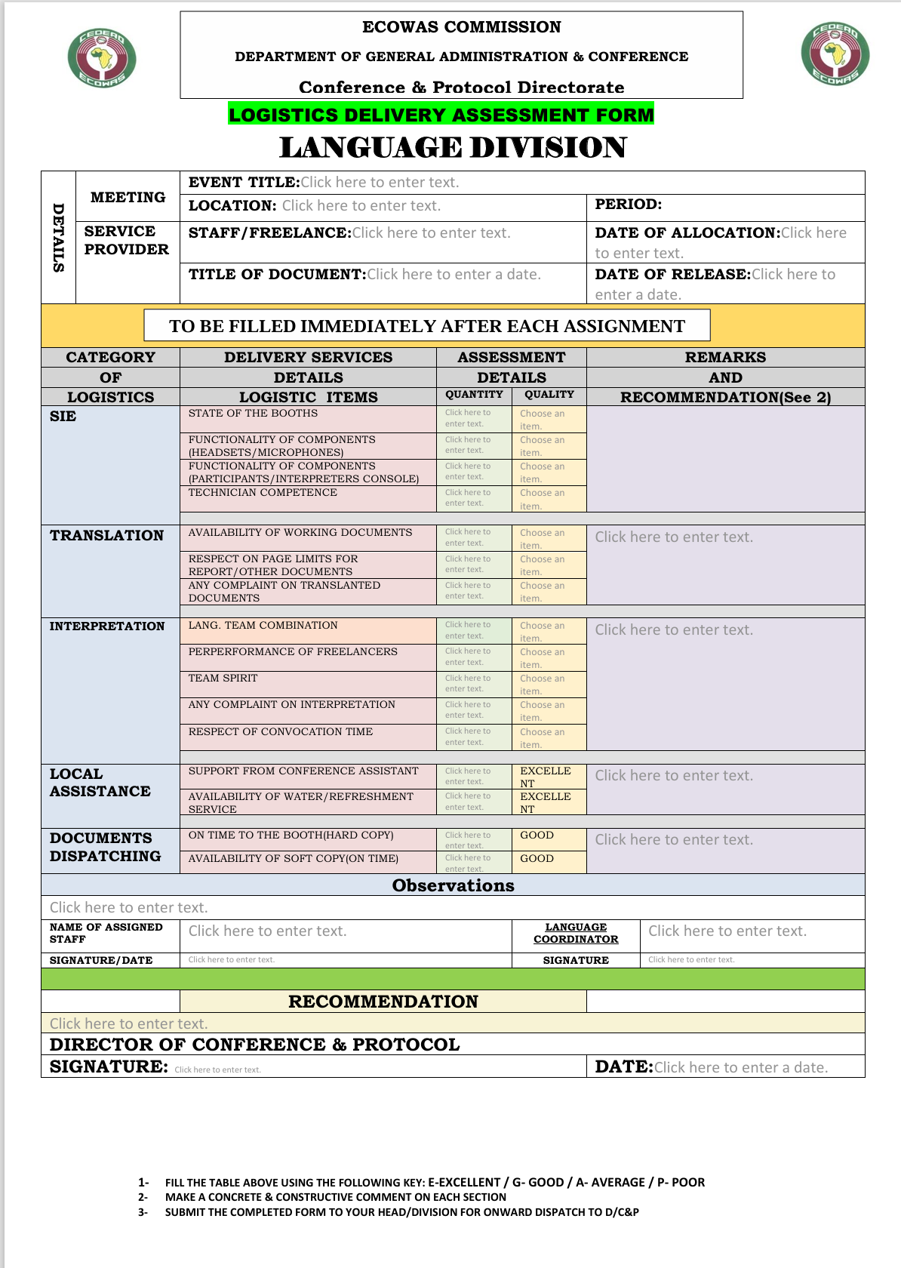

Logistics Delivery Assessment Form: Conference Division

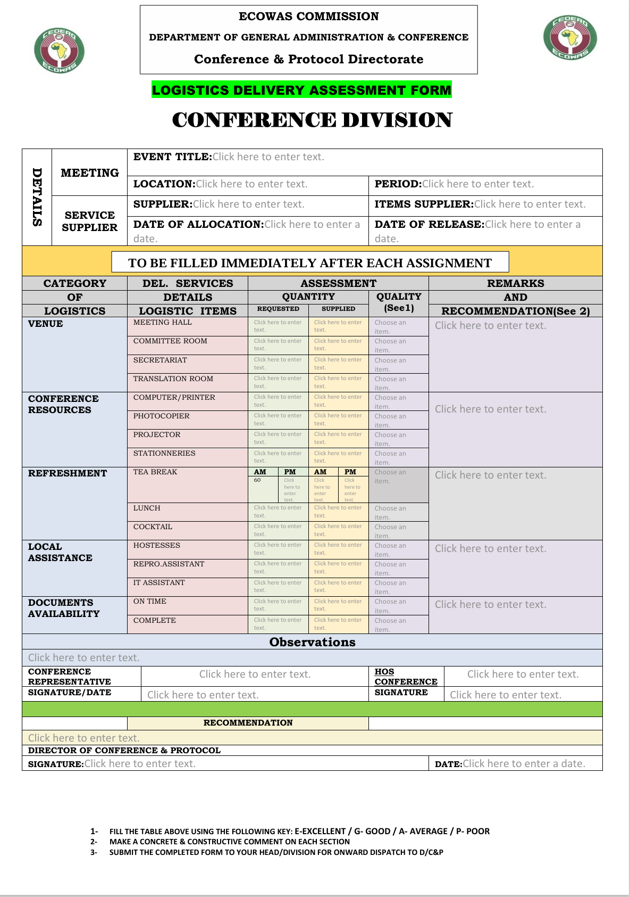

Logistics Delivery Assessment Form: Protocol Division

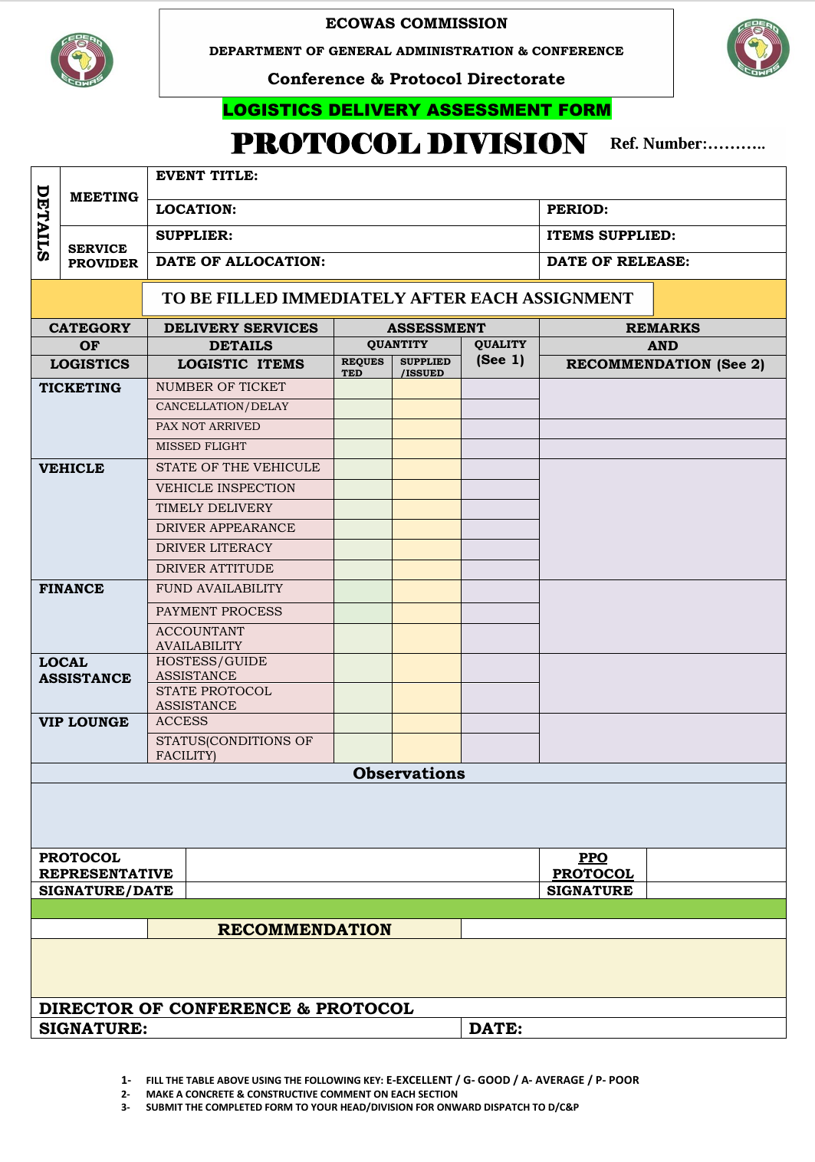

Meeting Logistics Details Form
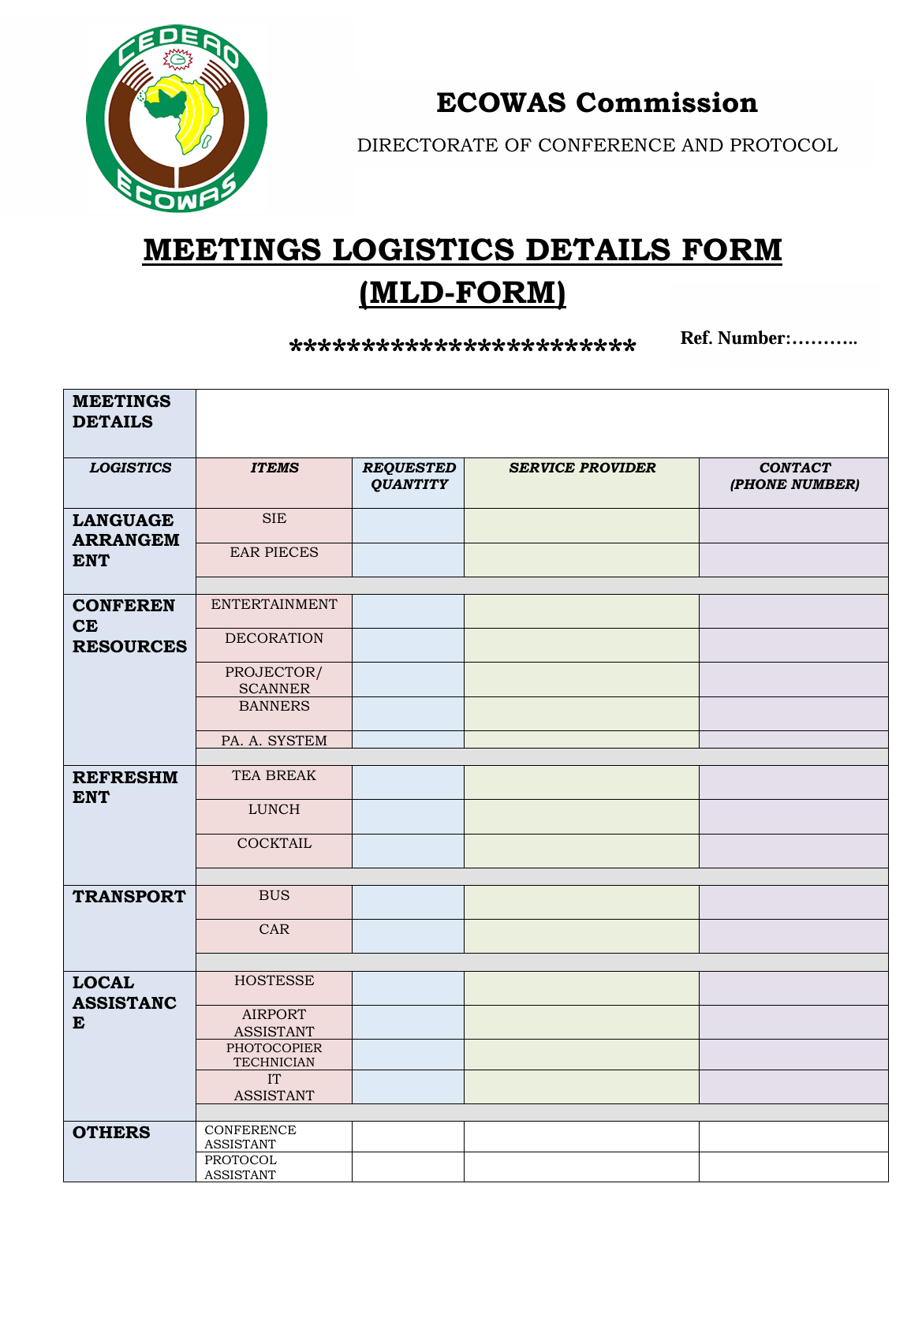

Delegate Feedback Form

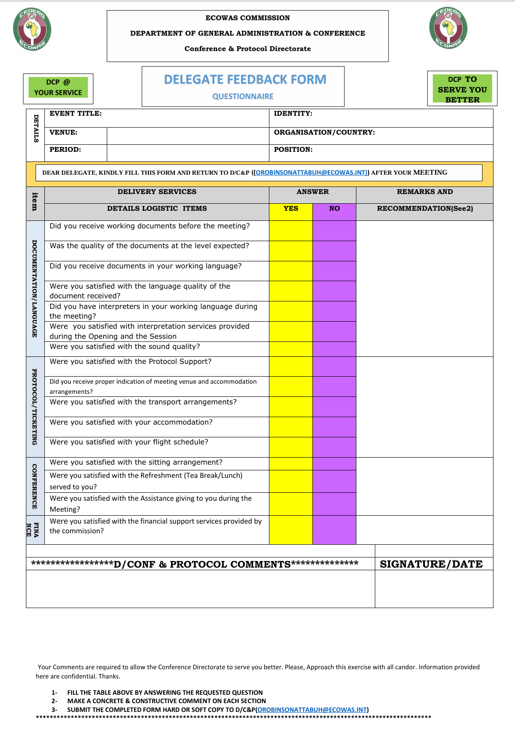

ECOWAS Meeting Assessment Form

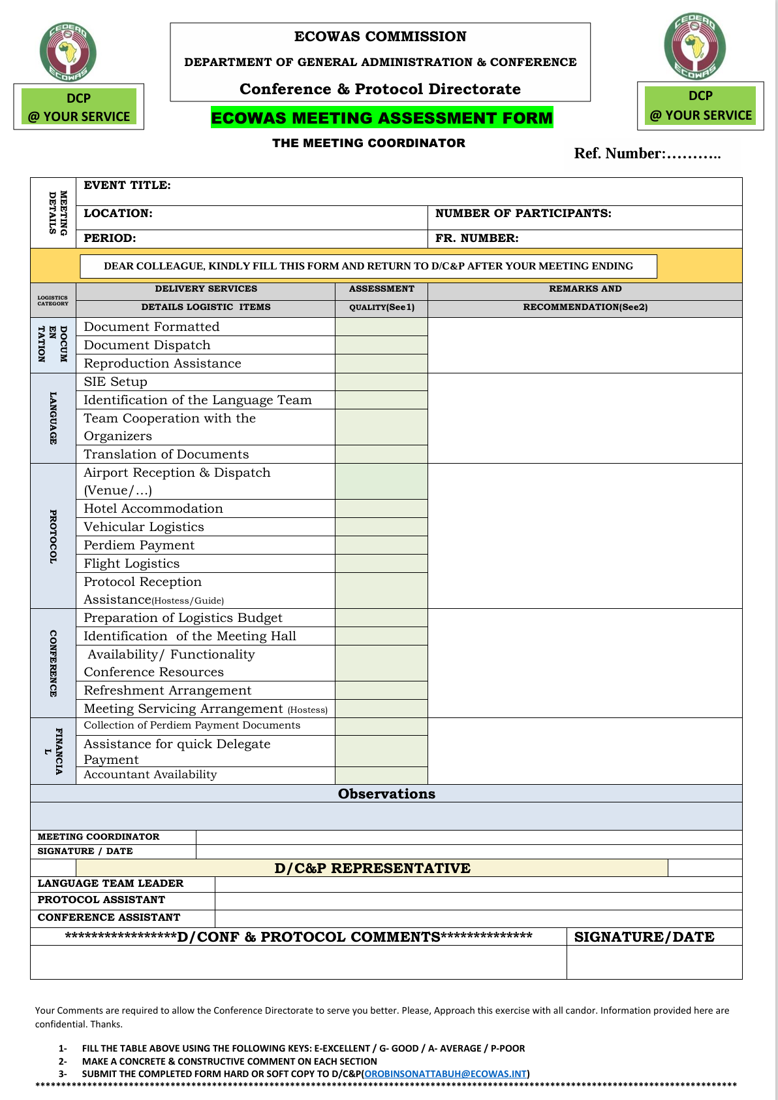

Assessment Logistics Preparation Sheet

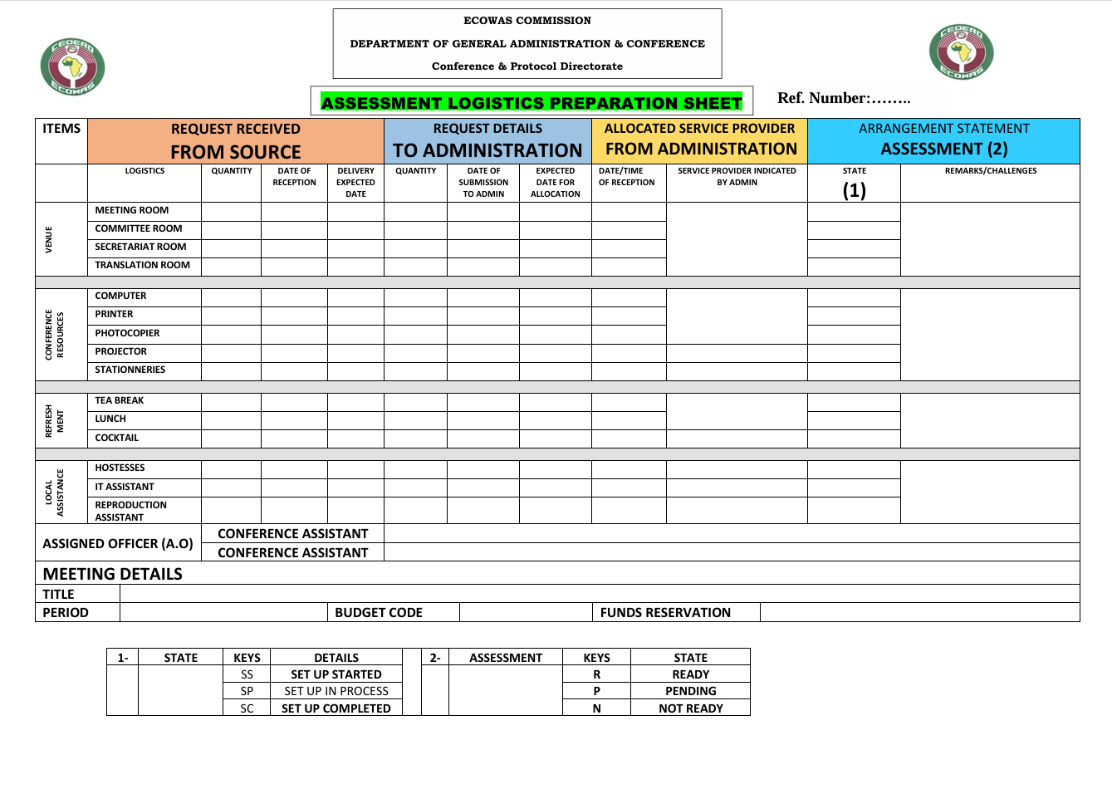

Form for Request for Issuance of Ticket for Freelance Interpreters

Virtual Meeting Request Form

